I went there to _________________

Please choose 3 places in Nagano. What did you do there?

- _____________________
I went there to ________________________________
- _____________________
___________________________________________________
- _____________________
__________________________________________________

Name | Have you been to __________? | Why did you go there?
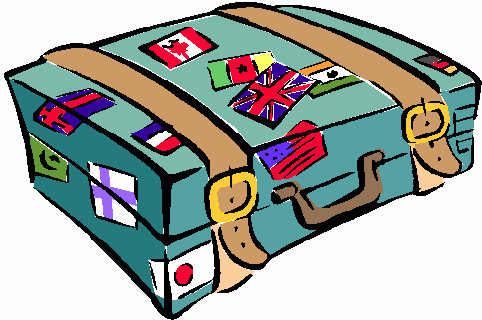

What did your friends say?

(例) Kano went to Hakuba to ski.

- _________________________________________
- _________________________________________
- _________________________________________
- _________________________________________

