Christmas presents
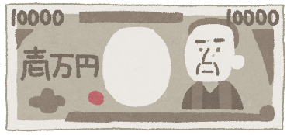
Merry Christmas! Santa will give you 10,000 yen!

What will you give to your family?

person | gift
 | I’ll give [ him / her ] a

How about your friends?

Name | Who will you give a present to? | What will you give him/her?

