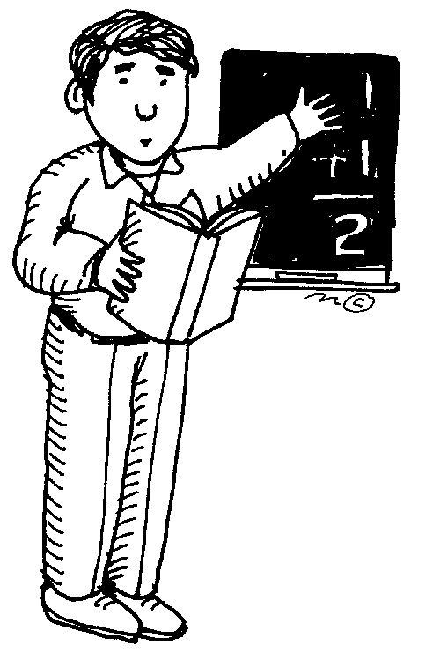
EXAMPLE:
Mr. Kudo ( He / She ) is a teacher who plays volleyball.

Teacher 1  Name: ____________ | ( He / She ) is a teacher who ___________________________.  ( He / She ) is a teacher who ___________________________.  ( He / She ) is a teacher who ___________________________.

Teacher 2  Name: ____________ | ( He / She ) is a teacher who ___________________________.  ( He / She ) is a teacher who ___________________________.  ( He / She ) is a teacher who ___________________________.

Let’s guess the student!

Student  Name: ____________ | ( He / She ) is a student who ___________________________.  ( He / She ) is a student who ___________________________.  ( He / She ) is a student who ___________________________.

