Name ________________________ Class ______ Number ______

**Step 1:** Look at the pictures with your partner and read the dialogue.

. Yes, please. I like these ̴̴̴̴.

. Something ̴̴̴̴.

. Oh, that’s cool.

But it’s too ̴̴̴̴ for me.

. Yes, please.

. Oh, this is nice. How much is it?

. Ok. I’ll take it.

. Hello. May I help you?

. We have more in the back.

What color are you looking for?

. How about this one?

. Shall I show you a ̴̴̴̴ one?

. It’s ̴̴̴̴ dollars.

1

hats

pants

shoes

2

3

small

big

4

bigger

smaller

**Step 2:** Write an original dialogue with your partner and perform it together.

1. Hello. May I help you?

2. Yes, please. ______________________________

________________________________________________

3. We have more in the back. _________________________________________________

________________________________________________

4. Something _______________________________

5. How about ___________________________________________________

6. Oh, that’s cool. But _______________________

____________________________________________________________

7. Shall I ____________________________________________________________________

8. Yes, please.

9. Oh, _____________________________________

______________________________________________

10. It’s _____________________________________________

11. Ok. ________________________________

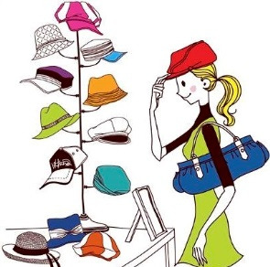

**1**

**2**

Something bright.

Something .

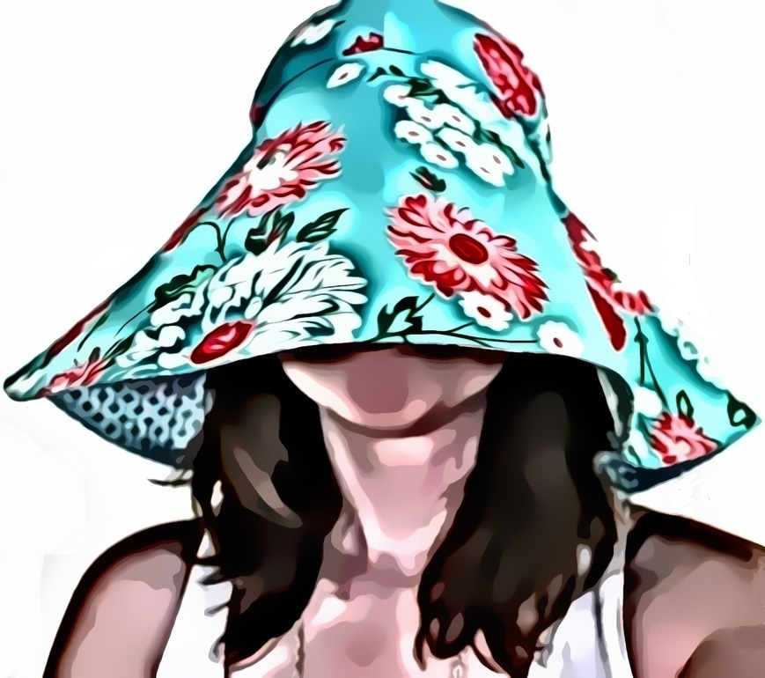

**3**



**$77**

**4**



**1**

Something green.

**2**

Something comfortable.



**3**



**$55**

**4**

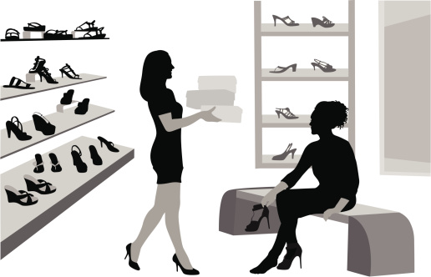

**1**

**2**

Something red.

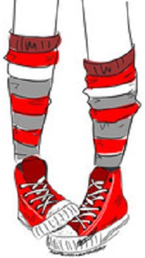



**3**

**$34**

**4**



**1**

**2**

Something pink.

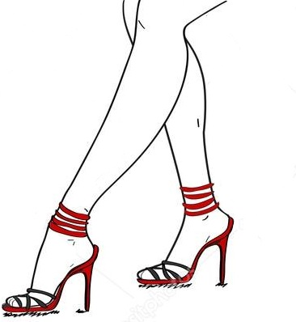

**3**

**$99**

**4**



**1**

**2**

Something blue.

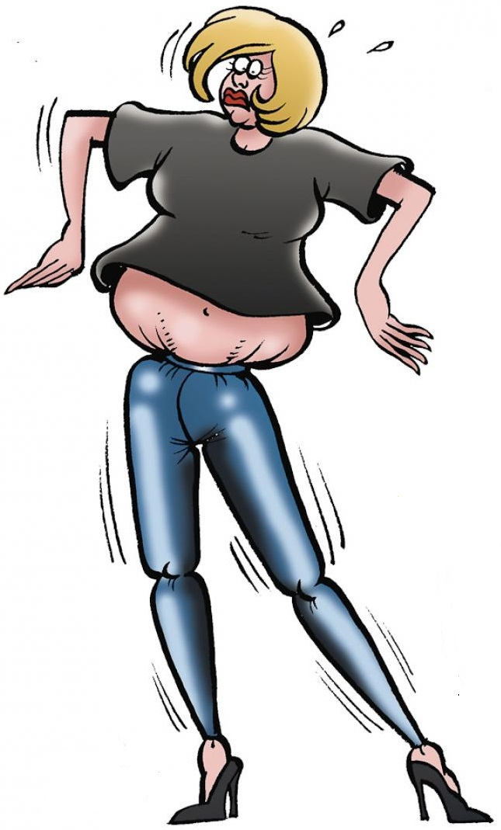

**3**

**$65**

**4**



**1**

**2**

Something blue.



**3**

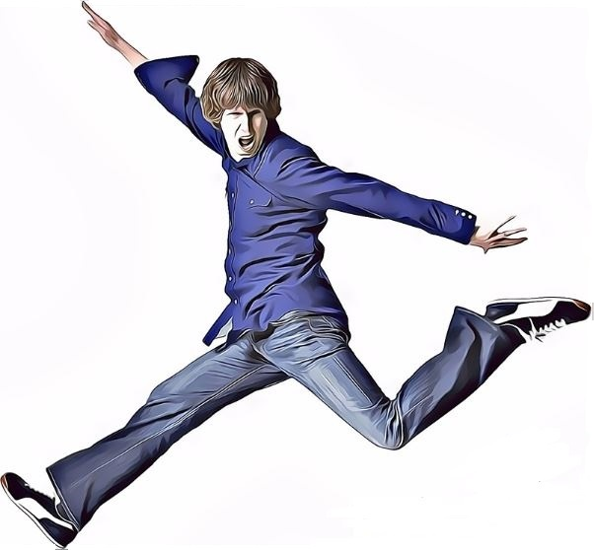

**$80**

**4**