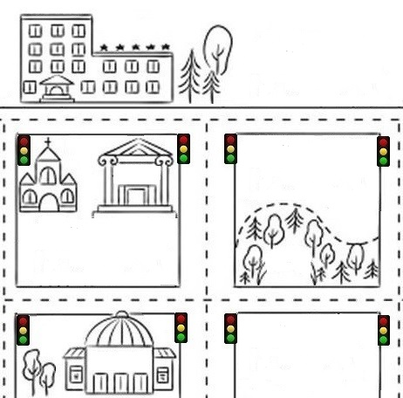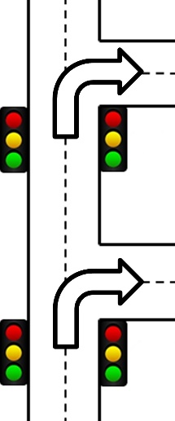Name _______________________ Class______ Number ______

Book store

本屋

Hospital

病院

City Hall

市役所

Gas station

**ガソリンスタンド**

Church

教会

**Sam Street**

**Alex Street**

**Park**

First traffic light

Second traffic light

**Turn right at the second traffic light**

**Turn right at the first traffic light**

**Excuse me.**

**I'm looking for the...**



**Use the information and perform the dialogue with your partner.**

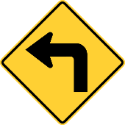

**Hospital**

**Map**

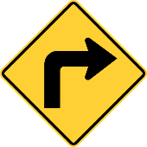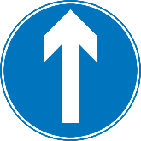

**Turn left**



**Go down this street**

**Turn right**

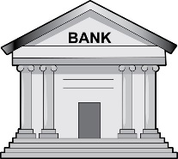

**Post office**

**You can see it on your left.**

**Church**

**City Hall**

**Tom Street**

Park

公園

Library

図書館

Post office

郵便局

Stadium

競技場

Station

駅

**Perform the dialogue with your partner.**

. Pardon me?

. Let’s see… Go down ~~~~~~~~ street.

Turn at the traffic light.

You can see it on your .

. You’re welcome.

. Excuse me. I’m looking for the...

. I’m looking for the...

. Thank you.

gas station.

library.

station.

stadium.

book store.

first

second

left

right

left

right

Name ___________________________　　　　　　　　　　　　　　　　 Class______ Number ______

Book store

本屋

Hospital

病院

City Hall

市役所

Gas station

**ガソリンスタンド**

Church

教会

**Sam Street**

**Alex Street**

First traffic light

Second traffic light

**Turn right at the second traffic light**

**Turn right at the first traffic light**

**Excuse me.**

**I'm looking for the...**



**Use the information and perform the dialogue with your partner.**



**Map**

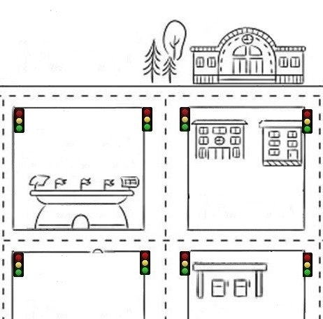

**Station**

**Turn left**



**Go down this street**

**Turn right**



**Library**

**Book store**

**You can see it on your left.**

**Stadium**

**Gas station**

**Tom Street**

Park

公園

Library

図書館

Post office

郵便局

Stadium

競技場

Station

駅

left

right

left

right

city hall.

church.

park.

post office.

hospital.

. Pardon me?

. Let’s see… Go down ~~~~~~~~ street.

Turn at the traffic light.

You can see it on your .

. You’re welcome.

. Excuse me. I’m looking for the...

. I’m looking for the...

. Thank you.

**Perform the dialogue with your partner.**

first

second

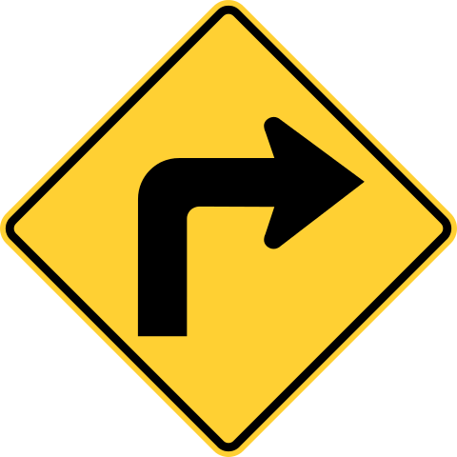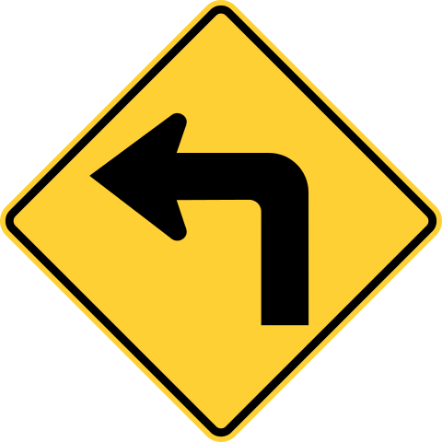

**Tom Street**

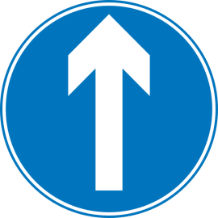

**Turn right.**

**Turn left.**

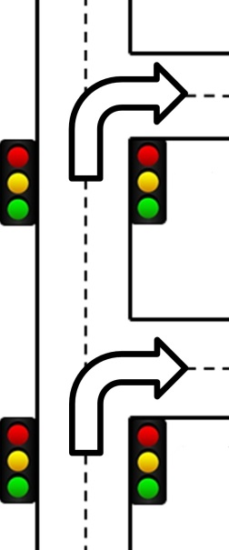

**Turn right at the second traffic light**

**Go down Tom Street.**

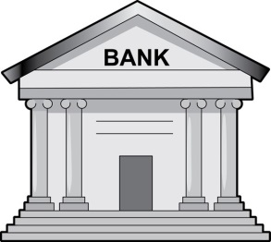

Second traffic light

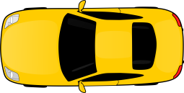

**Turn right at the first traffic light**

First traffic light

**You can see it on your right.**

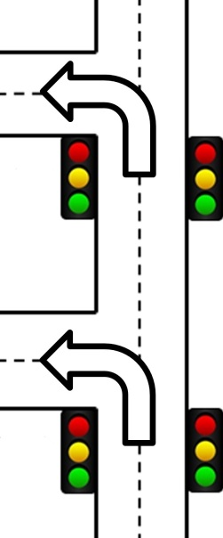

**Turn left at the second traffic light**



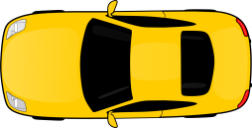

Second traffic light

**Turn left at the first traffic light**

**You can see it on your left.**

First traffic light

. Excuse me. I’m looking for the post office.

. Pardon me?

. I’m looking for the post office.

. Let’s see… Go down Tom Street.

Turn left at the second traffic light.

You can see it on your left.

. Thank you.

. You’re welcome.