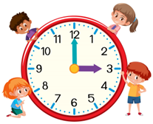
What time do you…?

~Talk to your classmates! Find out what their day looks like!~
What time do you get up? |  | What time do you have breakfast?  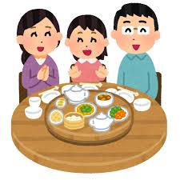
自分の答え
相手の答え
相手の答え
What time do you go to bed?  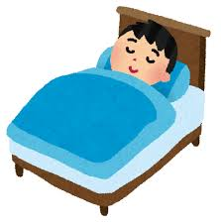 |  | What time is it in New Zealand now?
自分の答え
相手の答え
相手の答え

