FINAL CHALLENGE – RIDDLES (謎)

You have finally reached the treasure! But in front of you stands a huge dragon (龍)! The dragon looks far stronger than you.

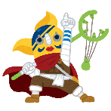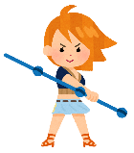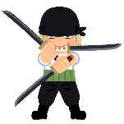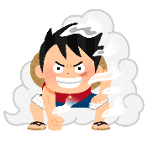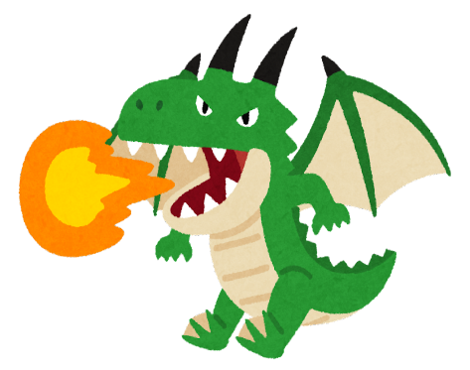

The dragon looks at you and says: "It is lucky for you that I am not hungry today. You may have the treasure... if you can answer my riddles.

Answer the riddles below:

- J, F, M, A, M, J, J, A. What are the next two letters?

- You are my brother, but I am not your brother. What am I?

- A woman and 9 friends are under a small umbrella, but nobody gets wet. Why?

