Challenge 3 – LOGIC

You have your crew! It’s time to set sail for Laugh Tale Island!

You go the port, but there are lots of ships and you can’t remember which one is yours. You try to remember everything you know about the different ships.

Using the clues below, add the missing information to the table:

Captains (船長): Big Mom, Boa, Buggy, Kuro, Luffy, Shanks (every ship has a different captain)
Sails (帆): 1, 2 or 3
Figurehead (置物): Bird, Fish, Flower, Horse, Lion, Sun (every ship has a different figurehead).

Clues:
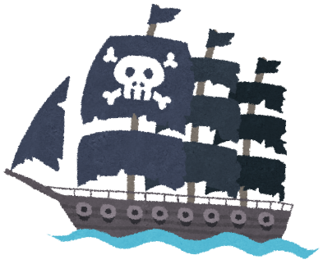
- Luffy's ship has fewer sails than Shank's ship.
- Buggy's ship does not have a bird figurehead.
- Luffy's ship has a figurehead of something which is in the sky.
- Big Mom's ship has the same number of sails as Luffy's ship.
- Kuro's ship has fewer sails than everyone else.
- The figurehead on Shank's ship has 4 legs.
- Boa's ship has more sails than Buggy's ship
- The figurehead on Big Mom's ship has no legs.

Captain |  | Shanks | Kuro |  |  | Big Mom
Sails | 2
Figurehead | Fish |  | Horse |  | Flower

