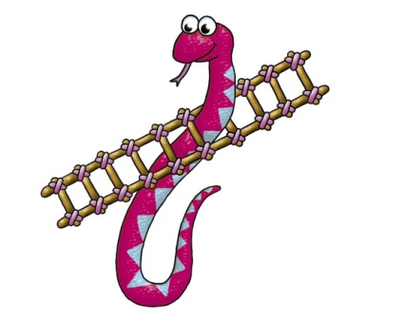
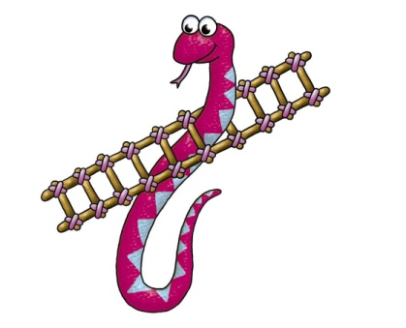
Snakes and Ladders!
85 DO SPIN!  8X | 86 | 87 GO BACK!  3X | 88. DO CLAP!  10X | 89 | 90.  GOAL
84. | 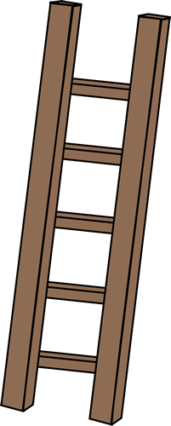  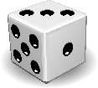  83 ONE  MORE  TIME! | 82. GO BACK!  1X | 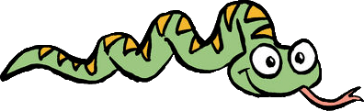  81 | DO CLAP! 80  5X | 79. GO BACK!  2X
73 SENTENCE!  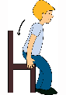 | 74 | 75 What animals do you like? | 76  SENTENCE! | 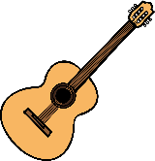  77 SENTENCE! | 78 What time is it?  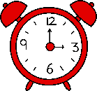
72 | 71 DO FUNNY FACE! | 70 | 69 How are you? | 68 | 67 DO FUNNY FACE!
61. GO BACK!  2X | 62 | 63 | 64 | 65 | 66 How is the weather?
60 SENTENCE! | 59  ONE MORE TIME! | 58 Do you like natto? | 57 DO SPIN!  3X | SENTENCE! 56 | 55 SENTENCE!
49 | 50  TWO MORE TIME! | 51 GO BACK!  2X | 52 Say  “Hi” to  Ms. Wendy | 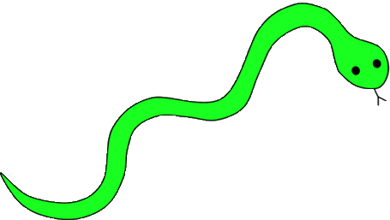  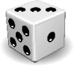  53 TWO  MORE  TIME! | 54. GO BACK!  1X
48 DO CLAP!  4X | 47. GO BACK!  2X | 46 What time is it? | 45 | 44 Say “Hi”  to  Ms. Wendy | 43 SENTENCE!
37 | 38 SENTENCE! | 39. GO BACK!  1X | 40 | 41 SENTENCE! | 42  TWO MORE TIME!
36 Say  “Hi” to  Ms. Wendy | 35 What food do you like? | 34 DO CLAP!  3X | 33 | 32 SENTENCE! | 31 How are you?
25 | 26  ONE MORE TIME! | 27 | 28. GO BACK!  2X | 29 | 30 SENTENCE!
24 | 23 | 22 SENTENCE! | 21 DO FUNNY FACE! | 20 DO  CLAP!  3X | 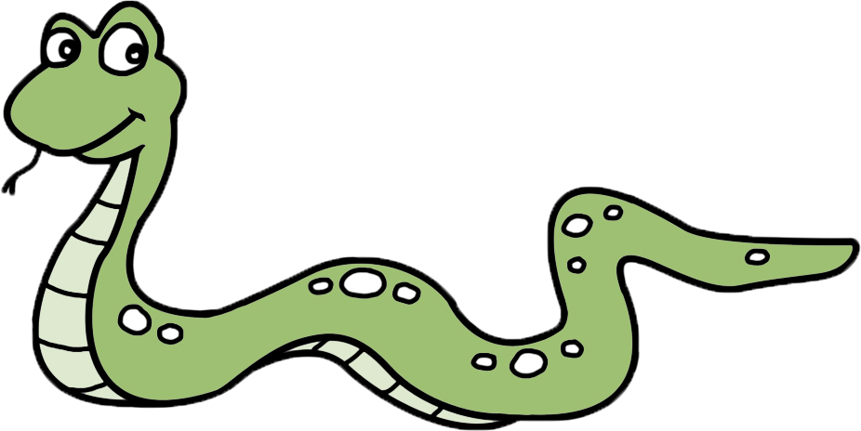  19
13 | 14 SENTENCE!  数学 | 15 GO BACK!  2X | 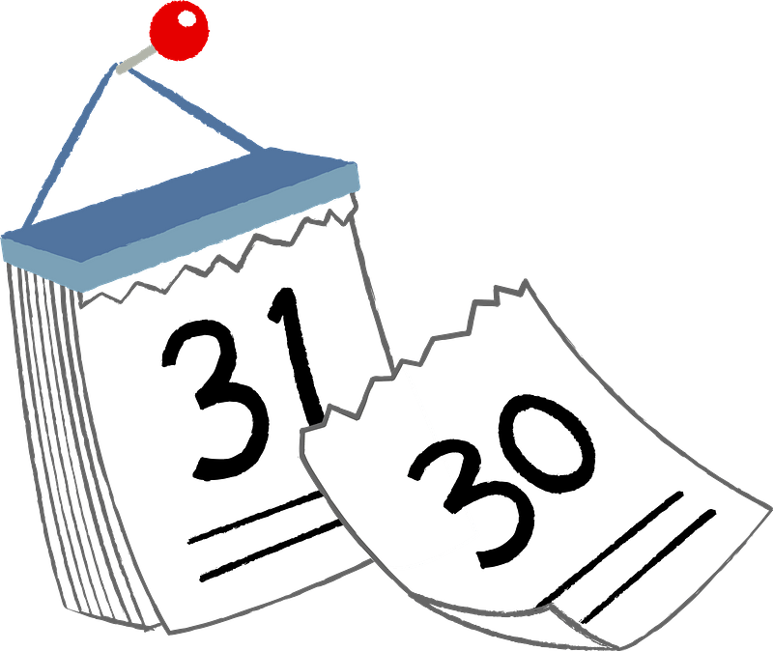  16 What’s the date? | 17 SENTENCE! | 18
12 SENTENCE! | 11 Are you from Japan? | 10 DO SPIN!  3X | 9 | 8 What day is it? | 7 DO FUNNY  FACE!
1  START | 2  ONE MORE TIME! | 3 What sports do you like? | 4 SENTENCE!  英語 | 5 | 6

