Super Superlatives! ➁
Step 1: Interview.
Question | Answer
- Who is the funniest person you know? | ________________ is the funniest person I know.
- What is the most delicious food? | __________________ is the most delicious food.
- Where is the best place to visit in Japan? | ____________________ is the best place to visit.
- What is the most important subject to study? | _________________ is the most important subject.
- Who is the most interesting anime character? | _______________ is the most interesting character

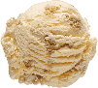
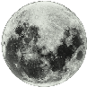
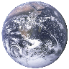
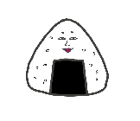
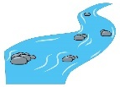
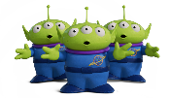
Step 2: Research activity. First guess, then find the real answers with your partner.
Question | Guess | Answer
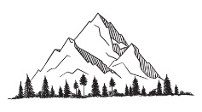  - What is the tallest mountain in the United States? | I guess:  __________________ is. | ________________ is the tallest mountain.
- What is the longest river in Africa? | I guess:  ___________________ is. | ________________ is  the longest river.
- What is the largest city in the world? (by population) | I guess:  ___________________ is. | _______________ is the largest city.
- What is the second biggest prefecture in Japan? | I guess:  ___________________ is. | ______________ is the second biggest.
- What is the most popular ice cream flavor in Japan? | I guess:  ___________________ is. | _______________ is the most popular flavor.
- Where is the deepest place on Earth? | I guess:  ___________________ is. | _______________ is the deepest place.
- What is the spiciest chili pepper in the world? | I guess:  ___________________ is. | ________________ is the spiciest.
- Which planet has the most moons?  (confirmed and provisional moons) | I guess:  _________________ does. | _______________ has the most moons.
- Which planet has the shortest day? | I guess:  _________________ does. | _______________ has the shortest day.
- What is the cheapest rice ball at Lawson? *(You can use Japanese here) | I guess:  ___________________ is. | _______________ is the cheapest.
- I guessed ________________ out of 10 correctly. ★
Step 3: Make some sentences.
➀ ________________________________________________________________________________________________.
➁ ________________________________________________________________________________________________.
➂ ________________________________________________________________________________________________.
➃ ________________________________________________________________________________________________.
Name ( ) Class ( ) No ( )

