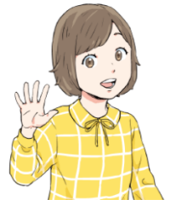
New Horizon 1 Year-end review
Where was that phrase?

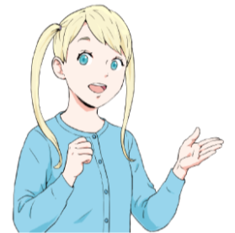
Part 1: Look in the book!
Look at the stories from your textbook. Try to find these
phrases or sentences. Write the page number.

ex: Nothing special. page 106
- What’s happening? page ________
- Don’t worry. page ________
- Let’s eat something. page ________
- Good! Me, too. page ________
- We had a wonderful time. page ________
- It’s always very crowded. page ________
- Be careful with that. page ________
- This park is usually quiet. page ________
- …but he gets a lot of nice comments. page ________
- I wanted to show this to you. page ________
- They’re getting clean water from a well. page ________
- Someday I want to play in the World Cup. page ________
Review: Practice saying these phrases with a partner.

New Horizon 1 Year-end review Where was that phrase?
Part 2: They Have the Same Meaning!
Read these sentences:
We enjoyed ourselves.
I want to be on the Japanese national soccer team.
It’s not usually so busy here.
I’d like you to see something.

People say many good things.
Don’t lose it.
Don’t be scared.
What’s up?
So do I.
I want some food right now.
It’s busy every day.
They’re pumping fresh water.

pumping: 汲み上げている
Try to match them with the sentences below.

1. What’s happening? | 2. Don’t worry.
3. Let’s eat something. | 4. Me, too.
5. We had a wonderful time. | 6. It’s always very crowded.
7. Be careful with that. | 8. This park is usually quiet.
9. He gets a lot of nice comments. | 10. I wanted to show this to you.
11. They’re getting clean water from a well. | 12. I want to play in the World Cup.

Review: Practice saying the old and new phrases with a partner.

