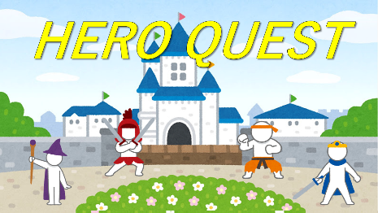
Name: ______________ Class: ____ Number: ____

- ________________________________________________________________
__________________________________________________________________
2, ________________________________________________________________
_________________________________________________________________
- ________________________________________________________________
__________________________________________________________________
- ________________________________________________________________
__________________________________________________________________
- ________________________________________________________________
__________________________________________________________________
- ________________________________________________________________
__________________________________________________________________
- ________________________________________________________________
__________________________________________________________________
- ________________________________________________________________
__________________________________________________________________
- ________________________________________________________________
__________________________________________________________________
- ________________________________________________________________
__________________________________________________________________
- ________________________________________________________________
___________________________________________________________________
- ________________________________________________________________
___________________________________________________________________

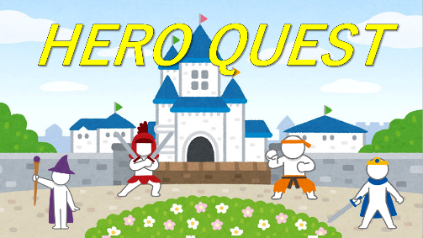
- What will you do if it rains on Sunday?
- What are you going to do tonight?
- What restaurant is there near your school?
- What do you want to do in high school?
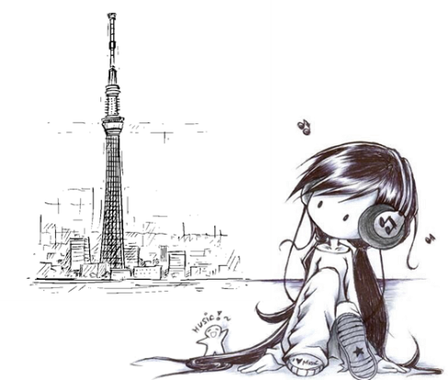
- What will Doraemon do if he sees a mouse?
- What is this girl going to do tomorrow?
- How many students are there in your class?
- What do people go to Okinawa to do?
- What won’t you do the weekend?
- Are you going to play basketball tomorrow?
- Is there an amusement park in your town?
- Does Nobita want to study?

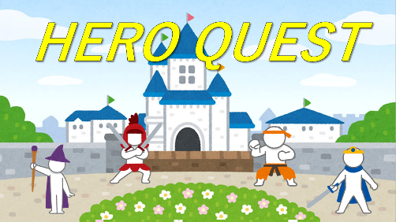
- What will you do if it rains on Sunday?
- What are you going to do tonight?
- What restaurant is there near your school?
- What do you want to do in high school?
- What will Doraemon do if he sees a mouse?
- What is this girl going to do tomorrow?
- How many students are there in your class?
- What do people go to Okinawa to do?
- What won’t you do the weekend?
- Are you going to play basketball tomorrow?
- Is there an amusement park in your town?
- Does Nobita want to study?

