4月 Unit 1 - 3rd Grade

1. Greetings.

2. Let's watch and think (世界のいろいろな挨拶).
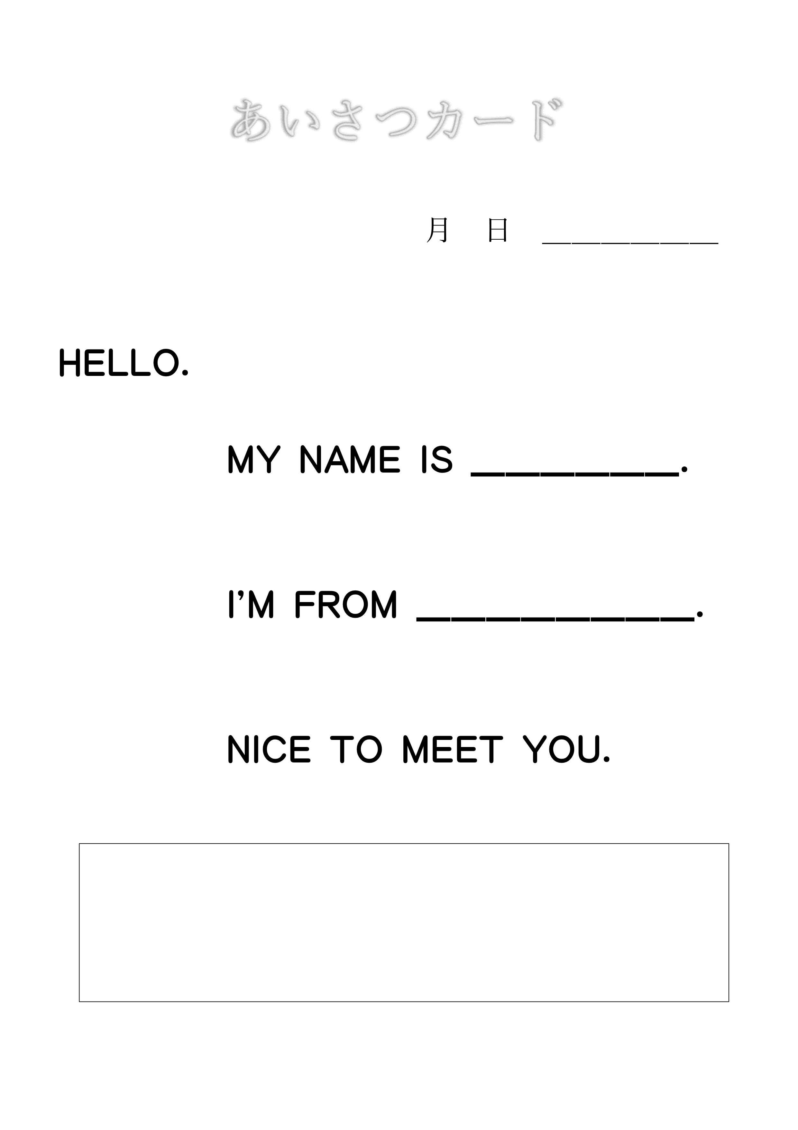
3. Let's CHANT: "Hello".

4. Let's listen page 4.

5. Activity: あいさつをしよう
+ Worksheet.

6. Greetings.

