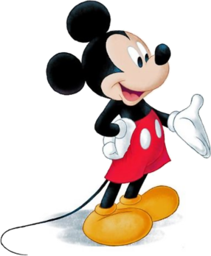
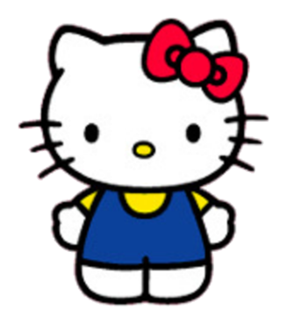
Mickey Mouse

Hello Kitty

Anpanman
He can swim far. | He can sing songs. | He can dance.
She can play soccer. | She can bake cookies. | She can play guitar.
He can cook curry. | He can eat natto. | He can speak English.
He can eat natto. | He can climb trees. | He can play tennis.
He can bake cookies. | He can speak English. | He can draw pictures.
He can swim far. | He can play soccer. | He can cook curry.
He can draw pictures. | He can play guitar. | He can play tennis
She can dance. | She can play games. | She can climb trees.
He can sing songs. | He can speak English. | He can play games.
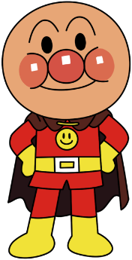
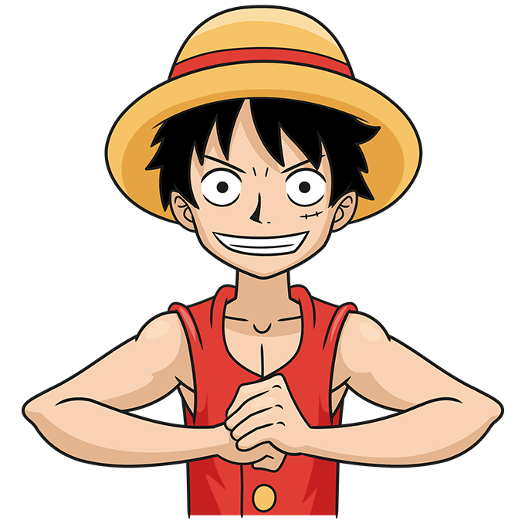
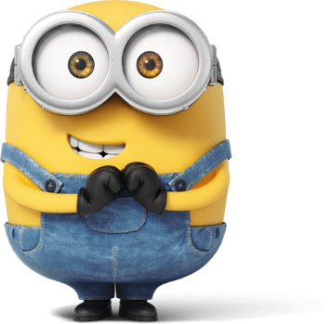
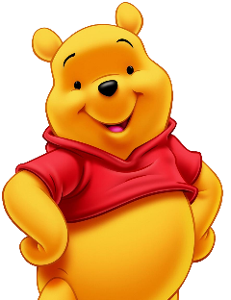
Anya

Pikachu

Luffy

Bob

Winnie the Pooh

Doraemon

