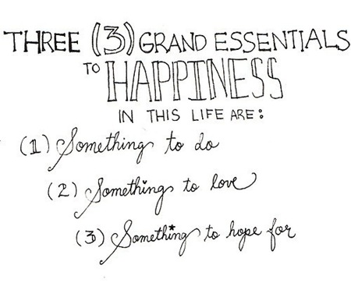
Name: _____________________

-Alan Chalmers

- ____________ is something to ____ in the ________.
- ______________ ___ something __ ____ in Italy.
- ____________ ___ something ___ ___on _____ _____’s day.
- _______ ___ something __ ____ on ________ on ______.
- ___________ ____ ____________ to _______in Australia.
- _____________ ____ __________ ___ _______in English class.
- __________ ___ _________to buy for your _________ _______.
- _____________ ___ __________ to _____ in the ____________.
- ___________ __ _______ ___ say at ______ in the __________.
- ____________ ____ __________ ____ ____ ____ _____________
- _____________________________________________________
Because _____________________________________________
- _____________________________________________________ Because ______________________________________________
1. What is something to play in the gym?

2. What is something to eat in Italy?

3. What is something to get on New Year’s Day?

4. What is something to watch on TV on Sunday?

5. What is something to see in Australia?

6. What is something to use in English Class?

7. What is something to buy for your mother’s birthday?

8. What is something to drink in the summer?

9. What is something to say at school in the morning?

10. What is something to buy in America?

11. What is something to see in Uonuma?

12. What is something to eat in Uonuma?

What is something to eat at Kappazushi?

______ is something to eat at Kappazushi.
What is something to ride at Disneyland?

____ is something to ride at Disneyland.
What is something to drink in the winter?

____ is something to drink in the winter.
What is something to play at home?

______ is something to play at home.
Hamburger sushi

Space Mountain

Hot Cocoa

Mario Kart

