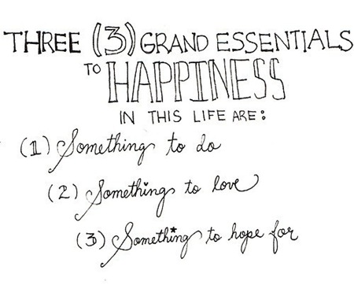
Name: _____________________ Number: ______

-Alan Chalmers

- ____________ is someone to ____ ________ with.
- ______________ ___ something __ ____ in Italy.
- __________ ___ someplace ___ ___on ____ ____’s day.
- ______ ___ something __ ___ on _______ on ______.
- __________ ____ ___________ to ______in Australia.
- _________ ____ ________ ___ ______in English class.
- _________ ___ _____to buy for ____ ______ ______.
- _________ ___ ________ to _____ in the _________.
- ________ ___ ______ ___ say at ___ in the ________.
- _______ ____ ________ ____ ____ ____ _________
- ___________________________________________
Because ____________________________________
- __________________________________________ Because ____________________________________
1. Who is someone to play tennis with?

2. What is something to eat in Italy?

3. Where is someplace to go on New Year’s Day?

4. What is something to watch on TV on Sunday?

5. What is something to see in Australia?

6. What is something to use in English Class?

7. What is something to buy for your mother’s birthday?

8. What is something to drink in the summer?

9. What is something to say at school in the morning?

10. Who is someone to meet in America?

11. What is something to see in Uonuma?

12. Where is someplace to visit in Uonuma?

What is something to eat at Kappazushi?

______ is something to eat at Kappazushi.
Who is someone to meet at Disneyland?

____ is someone to meet at Disneyland.
Where is someplace to visit in the winter?

____ is someplace to visit in the winter.

