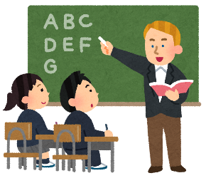
I want people to…
I want you to come to the mall with me.
My dad wants me to go to a good university.
The teacher wants everyone to enjoy English class.
例）I want ＿＿＿＿＿＿＿＿＿ to ＿＿＿＿＿＿＿＿＿＿＿＿＿＿＿＿＿＿＿＿＿＿＿＿＿.
人など
動詞の原形
- ＿＿＿＿＿＿＿＿＿＿＿＿＿＿＿＿＿＿＿＿＿＿＿＿＿＿＿＿＿＿＿＿＿＿＿＿＿＿＿.
- ＿＿＿＿＿＿＿＿＿＿＿＿＿＿＿＿＿＿＿＿＿＿＿＿＿＿＿＿＿＿＿＿＿＿＿＿＿＿＿.
- ＿＿＿＿＿＿＿＿＿＿＿＿＿＿＿＿＿＿＿＿＿＿＿＿＿＿＿＿＿＿＿＿＿＿＿＿＿＿＿.
Let’s ask our friends!
I want _______ to _________.
What do you want?
No. | Name | Who? | What?
例 | Tom | friends | to visit Miyazaki
1
2
3
例）＿＿＿＿＿＿＿ wants ＿＿＿＿＿＿＿ to ＿＿＿＿＿＿＿＿＿＿＿＿＿＿＿＿＿＿＿＿.
visit Miyazaki
his friends
Tom
- ＿＿＿＿＿＿＿＿＿＿＿＿＿＿＿＿＿＿＿＿＿＿＿＿＿＿＿＿＿＿＿＿＿＿＿＿＿＿＿.
- ＿＿＿＿＿＿＿＿＿＿＿＿＿＿＿＿＿＿＿＿＿＿＿＿＿＿＿＿＿＿＿＿＿＿＿＿＿＿＿.
- ＿＿＿＿＿＿＿＿＿＿＿＿＿＿＿＿＿＿＿＿＿＿＿＿＿＿＿＿＿＿＿＿＿＿＿＿＿＿＿.
Hint!! “my___________” “his/her/their_____________”

