Name: ____________ Class: _____ Number: _____
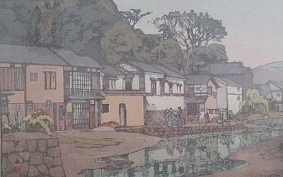
TOWN
MY

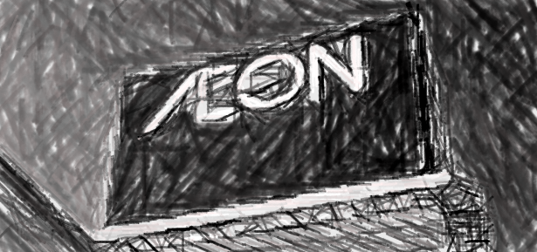
There are many shops.
I like Aeon.
You can play games in the game center.

- __________________________________
__________________________________
__________________________________

- __________________________________
__________________________________
__________________________________

- __________________________________
__________________________________
__________________________________

- __________________________________
__________________________________
__________________________________

