Hi, how are you?

I’m fine, thanks, and you?

I’m good, thanks.

What food do you like?

I like pizza. It is delicious.

Nice. I like sushi.

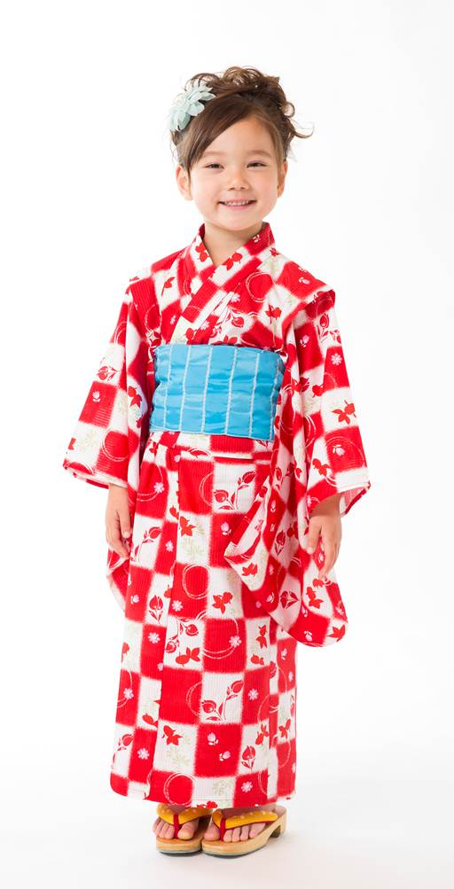
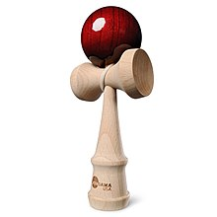
Cool. What sushi do you like?

I like maguro. It’s tuna.

Nice. What game do you like?

I like Uno. It’s fun.

Me too!

