d **Name: _________________**

**Step 1: Make questions in the simple past tense on line 1.**

**Step 2: Write the answers about *yourself* on line 2.**

1. what/ do?
2. where/ go?



1. what/ eat?



1. what/ buy?



1. who/ hang out with (一緒に過ごす)?



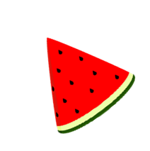 **Step 3: Ask the questions to four classmates.**

**Write the answers in the boxes below.**

Name: Name: Name: Name:

|  |  |  |  |
| --- | --- | --- | --- |
| 1. | 1. | 1. | 1. |
| 2. | 2. | 2. | 2. |
| 3. | 3. | 3. | 3. |
| 4. | 4. | 4. | 4. |
| 5. | 5. | 5. | 5. |

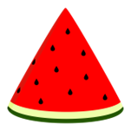

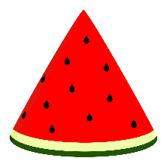 Step 4: Let’s play a ‘Quiz’ Game.

Be sure to use “3rd Person”.