USE English! HINT quiz

How much do you know about the world?
Here are some simple facts about some countries. Can you guess them?

Today’s point: Test your geography in English. Can you catch all meanings?

Question 1:
Hint 1: 3 points | Hint 2: 2 points | Hint 3: 1 point
______________ | ______________ | ______________

Question 2:
Hint 1: 3 points | Hint 2: 2 points | Hint 3: 1 point
______________ | ______________ | ______________

Question 3:
Hint 1: 3 points | Hint 2: 2 points | Hint 3: 1 point
______________ | ______________ | ______________

Question 4:
Hint 1: 3 points | Hint 2: 2 points | Hint 3: 1 point
______________ | ______________ | ______________

Question 5:
Hint 1: 3 points | Hint 2: 2 points | Hint 3: 1 point
______________ | ______________ | ______________
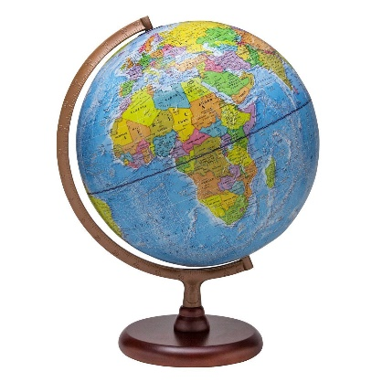
I got __________________ out of 15.

Name ( ) Class ( ) No ( )

