**Name: _________________**

**Step 1: Write the answers about *yourself*.**

**Step 2: Write the questions you will ask your classmates.**

1. One thing you DIDN’T DO this summer
2. The person you spent the most time with this summer



1. The best meal you ate this summer



1. Something educational you did this summer



1. Something you bought this summer



1. The best word to describe your summer



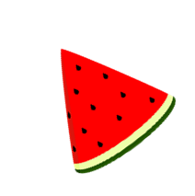 **Step 3: Ask the questions to four classmates.**

**Write the answers in the boxes below.**

Name: Name: Name: Name:

|  |  |  |  |
| --- | --- | --- | --- |
| 1. | 1. | 1. | 1. |
| 2. | 2. | 2. | 2. |
| 3. | 3. | 3. | 3. |
| 4. | 4. | 4. | 4. |
| 5. | 5. | 5. | 5. |
| 6. | 6. | 6. | 6. |

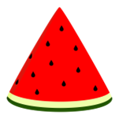

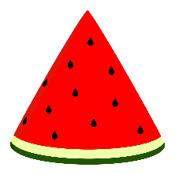 Step 4: Let’s play a ‘Quiz’ Game.

Be sure to use “3rd Person”.