A: This is a scene of the 21st century from Astro Boy created by Tezuka Osamu. What do you see in this video？
B: I see ________________________________________________________________
A: Mr. Tezuka predicted that the future would be like this.
What predictions have come true and haven’t come true?
B: I think ______________________________________________________________
______________________________________________________
What will the world look like in 50 years from now？
________________________________________________________________________________________________________________________________________________________________________________________________________________________________________________________________________________________________________________________________________________________________________________________________________________________________________________________________
Useful Expressions

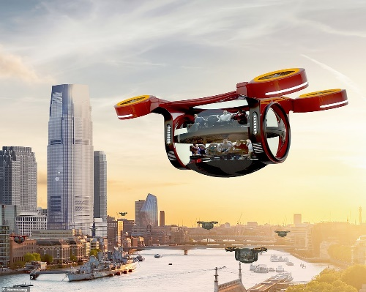 | 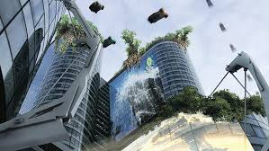
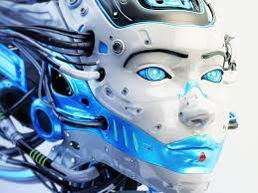 | 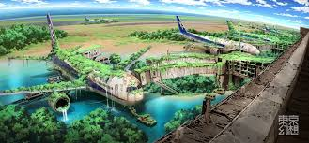
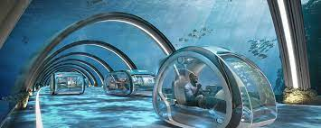 | 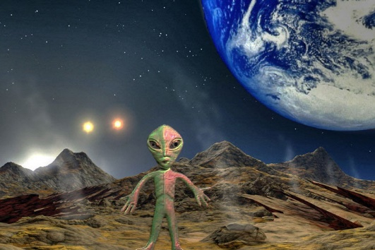
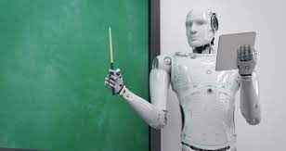 | 