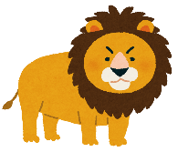  lion | 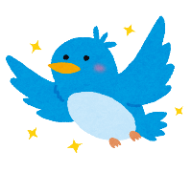  bird | 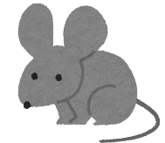  mouse | 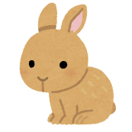  rabbit | 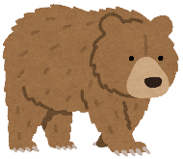  bear
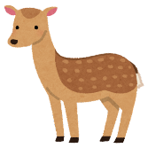  deer | 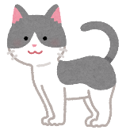  cat | 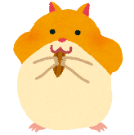  hamster | 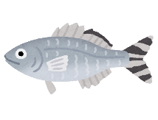  fish | 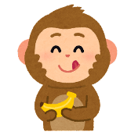  monkey
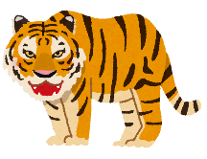  tiger | 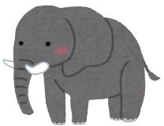  elephant | FREE | 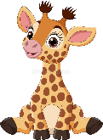  giraffe | 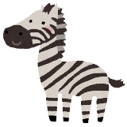  zebra
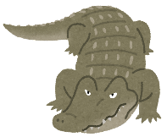  crocodile | 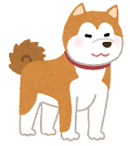  dog | frog | 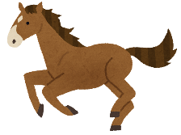  horse | 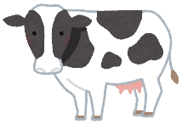  cow
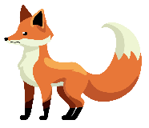  fox | 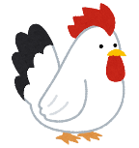  chicken | 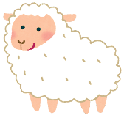  sheep | 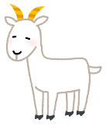  goat | 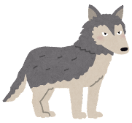  wolf

giraffe | dog | tiger | bear | deer
rabbit | monkey | sheep | cat | zebra
mouse | fox | FREE | lion | fish
frog | bird | elephant | crocodile | chicken
horse | wolf | hamster | cow | goat

frog | cow | crocodile | fish | bird
elephant | chicken | horse | rabbit | fox
goat | hamster | FREE | Wolf | sheep
mouse | giraffe | lion | deer | dog
monkey | cat | tiger | zebra | bear

zebra | monkey | cat | chicken | giraffe
goat | mouse | frog | tiger | crocodile
hamster | dog | FREE | bear | lion
fish | wolf | bird | elephant | fox
sheep | rabbit | cow | deer | horse

wolf | chicken | fox | frog | zebra
horse | sheep | lion | goat | dog
cow | elephant | FREE | cat | crocodile
bear | monkey | rabbit | deer | tiger
mouse | bird | fish | giraffe | hamster

dog | elephant | tiger | fox | lion
rabbit | zebra | monkey | wolf | bird
bear | fish | FREE | goat | giraffe
frog | deer | crocodile | mouse | sheep
hamster | cow | chicken | cat | horse

monkey | fish | goat | dog | elephant
mouse | cow | bear | frog | rabbit
wolf | zebra | FREE | chicken | hamster
tiger | lion | horse | fox | cat
sheep | deer | bird | giraffe | crocodile

goat | deer | hamster | horse | cat
bird | bear | chicken | sheep | wolf
giraffe | cow | FREE | tiger | elephant
fox | crocodile | monkey | rabbit | zebra
dog | mouse | fish | lion | frog

