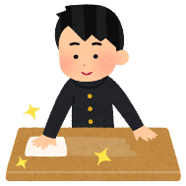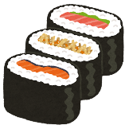

**Idea Box:**

|  |  |  |
| --- | --- | --- |
| travel to Tokyo by train | eat delicious sushi | take off your shoes |
| speak Japanese | bow at the shrine | use chopsticks |
| drink matcha | say “itadakimasu” | see Mt.Fuji |

**You/We will … / You/We can …**

1.______________________________________________________________________

2.______________________________________________________________________

**You/We may … / You/We must …**

1.______________________________________________________________________

2.______________________________________________________________________

Your friend is coming to Japan!

Please tell them your plan for the trip. And give them some advice about Japan!