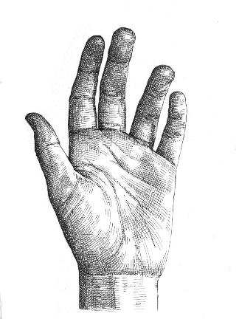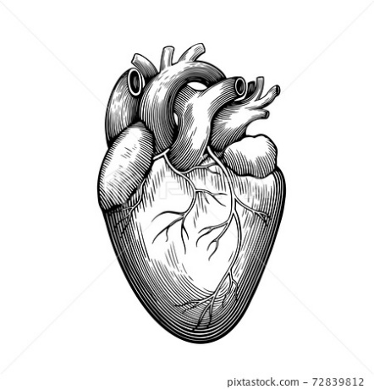

The Body

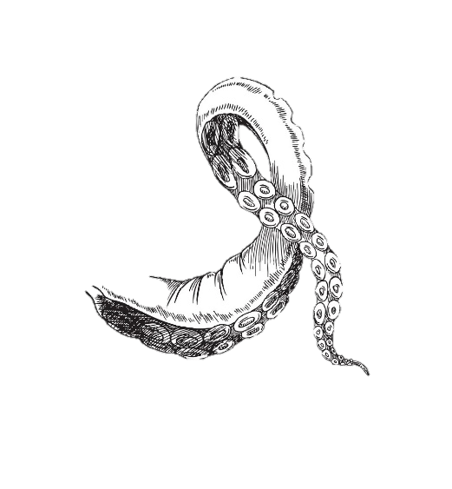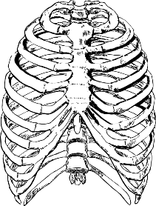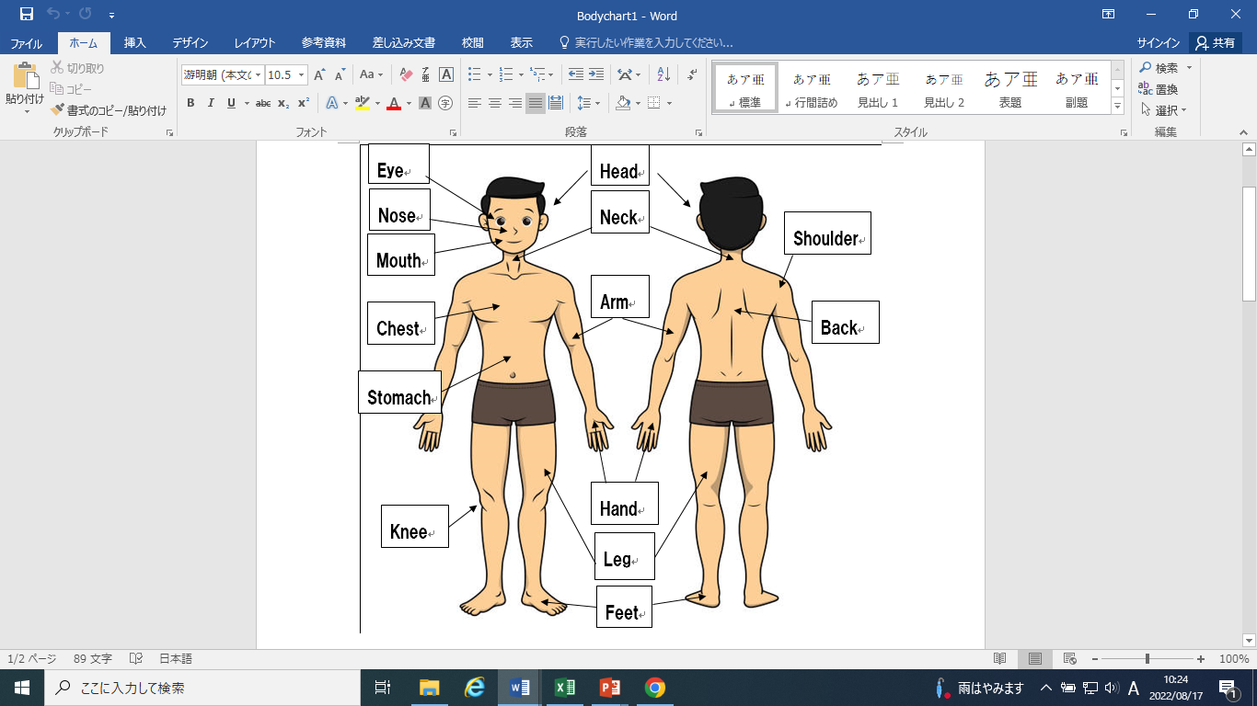

Finger

|  |  |
| --- | --- |
| 50+ Easy Horse Drawing Illustrations, Royalty-Free Vector Graphics & Clip  Art - iStock | Alien or martian cartoon illustration Stock Vector by ©izakowski 26895909 |
| Mouth: | Feet: |
| Eyes: | Eyes: |
| Legs: | Fingers: |