You have 9 ships.
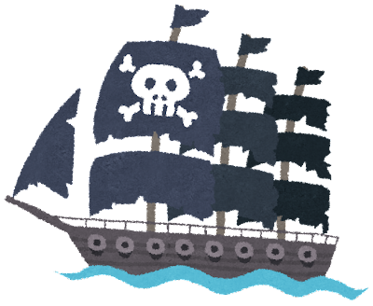

 | A) If Nick was a cat… | B) If Mr. Hoshino was a bird… | C) If Kota was a fish… | D) If Mr. Rios was a lizard… | E) If Hajin was a dog…
1) … would he have to go to school?
2) … would he have to wash the dishes?
3) … would he have to clean his room?
4) … would he have to speak English?
5) … would he have to eat vegetables?
Yes, he would. |  |  | No, he wouldn’t.

-----------------------------------------------------------------------------------------------------------------------------------------------------

 | A) If Nick was a cat… | B) If Mr. Hoshino was a bird… | C) If Kota was a fish… | D) If Mr. Rios was a lizard… | E) If Hajin was a dog…
1) … would he have to go to school?
2) … would he have to wash the dishes?
3) … would he have to clean his room?
4) … would he have to speak English?
5) … would he have to eat vegetables?

