Name: ____________________________
Class: __________
1. Choose the best caption for this picture.
a. This is my right hand. b. It’s nice to meet you. c. Goodbye d. Nice meet you.

2. Put the words in the right order to make a sentence.
than | Mount Fuji | Mount Everest | is higher

3. Otani has been playing baseball with the Los Angeles Angels since 2018. True False

4. I joined the volleyball team to ( ふさわしくないものを選んでください。)
a. make friends through sport b. make my body stronger
c. play in tournaments d. shoot many goals

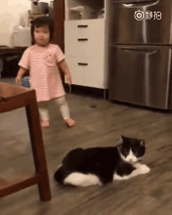
5. Choose the best sentence to match this gif (short loop video).
a. The cat made the little girl fall. b. The little girl made the cat fall.
c. The cat made the little girl walk. d. The cat maked the little girl fall.

6. What does the woman say about the new baby?

a. What is a cute baby! b. What cute baby! c. What a cute baby! d. What cute baby?

7. Mr. Nakajima has never slept in a tent. True False

8. 年上の男性が応えた : ‘Yes, there is. It’s over there.’ 質問は何ですか
a. Is there a toilet in the park? b. What’s the time now?
b. Excuse me. Where is the public toilet? c. I’m looking for the café.

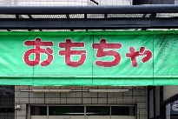
9. Is that a mochi (rice cake) shop?
a. No, it is. It’s a toy shop. b. No, is not. It’s a toy shop.
c. No, it’s not. It’s a toy shop. c. No, its not. It’s a toy shop.

10. What does the pirate say?
is | where | the treasure | I know

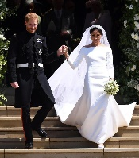
11. Meghan’s wedding dress was designed by . True False

12.
is possible | athletes show | anything | us that
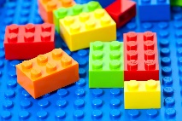
13. Where was Lego created?
a. in Sweden b. in Finland c. in Denmark d. in Norway

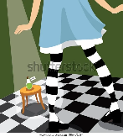
14. （アリスが薬を見た瞬間です。）Alice hasn’t drunk the potion ________.
a. already b. just c. now d. yet

15.
had | I wish | a million dollars （一億） | I
16.
was found | which | this is the mummy | in 1922

17. She finished ________ her homework.
a. did b. doing c. done d. already

18. The Japanese wolf can be seen in Hokkaido. True False

19. The evacuation drills _________ by the city are important.
a. hold b. held c. holding d. holds

20. I ______ a big sushi roll on February 3rd this year.
a. ate b. eat c. have eaten d. eated
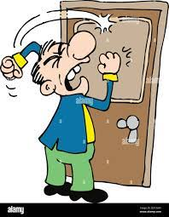
21. What is the best caption for this gif? (* someone is banging on the door)
a. Could you please open the door for me? b. Can you open the door for me?
b. Open the door!!! d. Can I open the door for you?

22. Which is right? (* a man is ordering food in a restaurant)
a. I’d like 1 cheese sandwiches. b. I like cheese sandwich.
c. I’d like 2 cheese sandwich d. I’d like a cheese sandwich.

23. She helped the old lady walk _______________. ( ふさわしくないものを選んでください。)
a. home b. to her house c. up the stairs d. to home

