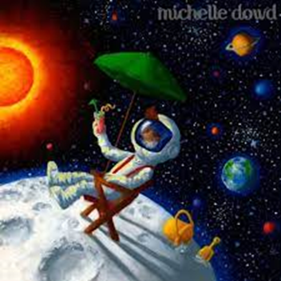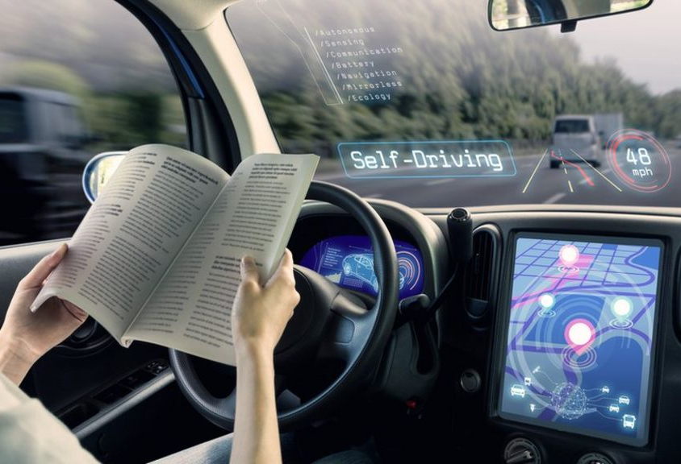
Hints
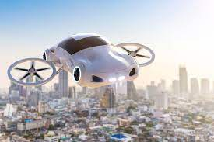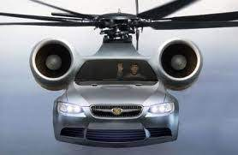
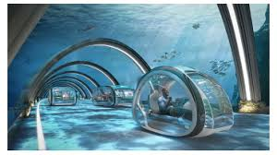

What will the world look like in 50 years from now?

I think in the next 50 years everything will be different. I predict that we will be able to go to the moon for vacation and holiday. We will be able to relax because Robots will cook and clean for us and do our laundry. I think we will have robot doctors. Our lifestyle will be changed because robots will do everything for us. In the next 50 years I think we will have flying cars so there will be no more traffic. I think we will have self-driving cars so we can read manga while car is driving.

