math | science | social studies | 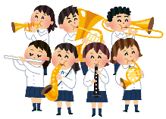  brass band | art
home economics | 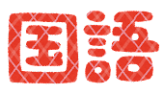  Japanese | 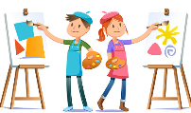  art club | 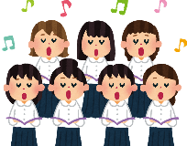  chorus club | 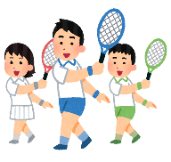  tennis team
P.E. | music | FREE | 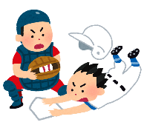  baseball team | 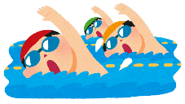  swimming meet
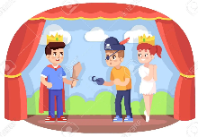  drama club | 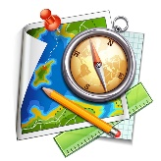  geography | 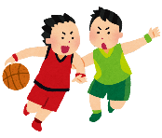  basketball team | 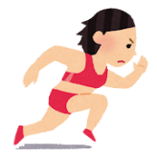  track and field | 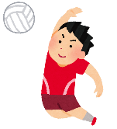  volleyball team
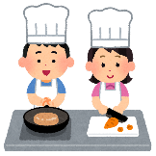  cooking club | 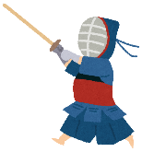  kendo club | 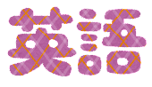  English | 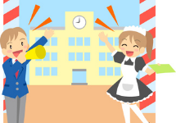  school festival | calligraphy

swimming meet | home economics | P.E. | art | science
tennis team | baseball team | track and field | kendo club | volleyball team
drama club | calligraphy | FREE | Japanese | math
chorus club | music | art club | geography | basketball team
school festival | English | brass band | cooking club | social studies

home economics | geography | calligraphy | track and field | drama club
swimming meet | school festival | chorus club | brass band | baseball team
science | P.E. | FREE | tennis team | Japanese
art club | cooking club | math | social studies | English
kendo club | music | volleyball team | art | basketball team

school festival | volleyball team | swimming meet | English | art club
baseball team | science | drama club | calligraphy | tennis team
basketball team | track and field | FREE | cooking club | home economics
social studies | P.E. | chorus club | geography | math
brass band | art | kendo club | music | Japanese

P.E. | baseball team | art club | geography | calligraphy
cooking club | volleyball team | tennis team | swimming meet | kendo club
art | basketball team | FREE | social studies | drama club
Japanese | math | science | English | school festival
music | track and field | home economics | brass band | chorus club

kendo club | brass band | music | cooking club | Japanese
English | social studies | baseball team | art | P.E.
tennis team | track and field | FREE | home economics | volleyball team
science | chorus club | school festival | calligraphy | art club
swimming meet | geography | drama club | baseball club | math

