Are you…? / Were you…?
現在形: Are you…? Yes I am / No I’m not
過去形: Were you…? Yes, I was. / No, I wasn’t
an elementary school student last year?  name: ____________ | cold now?  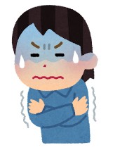  name: ____________ | sleepy yesterday?  name: ____________
hungry now?  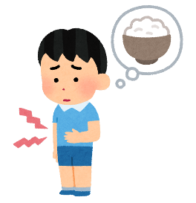  name: ____________ | a JHS student yesterday?  name: ____________ | happy yesterday?  name: ____________
at home yesterday?  name: ____________ | Japanese now?  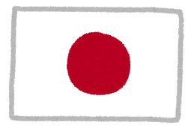  name: ____________ | a teacher now?  name: ____________

Challenge! Write TWO sentences:
例）Tom is a teacher now. / Tom was at home yesterday.
- ＿＿＿＿＿＿＿＿＿＿＿＿＿＿＿＿＿＿＿＿＿＿＿＿＿＿＿＿＿＿＿＿＿＿＿＿.

- ＿＿＿＿＿＿＿＿＿＿＿＿＿＿＿＿＿＿＿＿＿＿＿＿＿＿＿＿＿＿＿＿＿＿＿＿.

