Name: _______________________ Class: ______ Number: ______

What



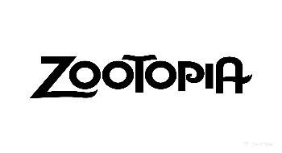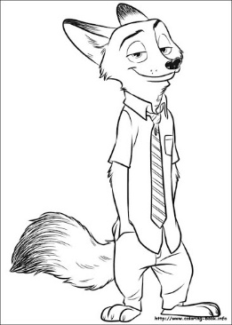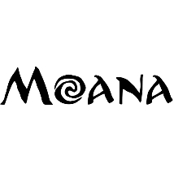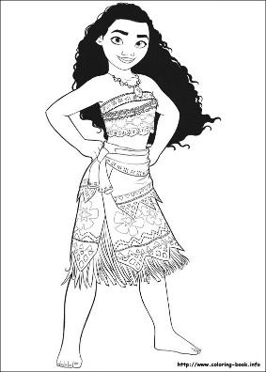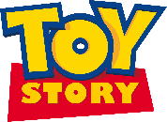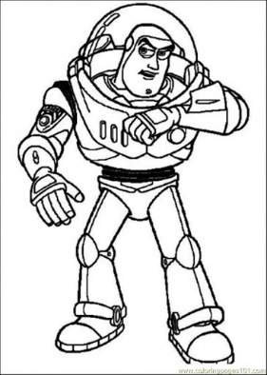

movie do you like?

no

no

no

no

no

no

no

no

no

yes

yes

yes

yes

yes

yes

yes

yes

no

yes

yes

Do you like shopping?

Do you like broccoli?

Do you like English?

Do you like volleyball?

Do you like soccer?

Do you like coffee?

Do you like ice cream?

Do you play the violin?

Do you play the guitar?

Do you play the piano?