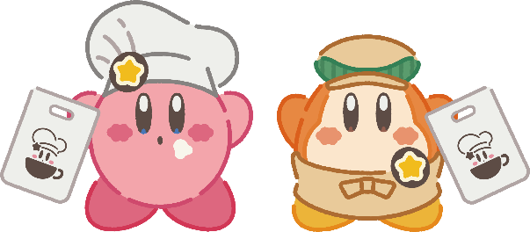 Name:_____________________

**First**, make the menu. Write the food names.

In pairs, take turns being the and .

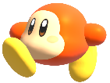

When you finish, ask other students.

＊**GOAL**: Eat **all** the food.

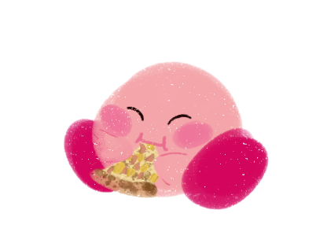 Which do you want a window seat or an outdoor seat?

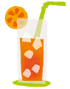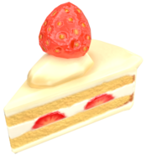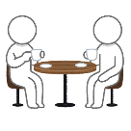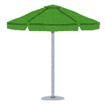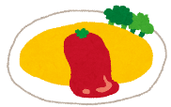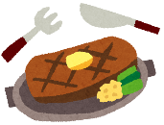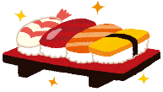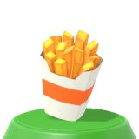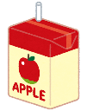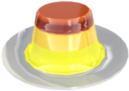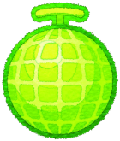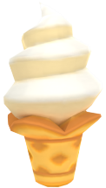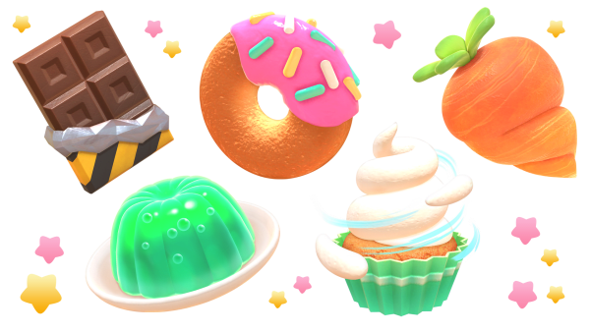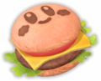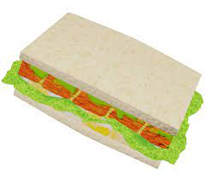 a window seat 　　　　　an outdoor seat

 Name:_____________________

**First**, make the menu. Write the food names.

In pairs, take turns being the and .



When you finish, ask other students.

＊**GOAL**: Eat **all** the food.

 Which do you want a window seat or an outdoor seat?

 a window seat 　　　　　an outdoor seat  
  
  
  
　　　apple juice orange juice coffee melon juice

**an** omurice/omelet **a** hamburger  **a** sandwich french fries **a** steak sushi **a** fried egg  
  
  
  
  
  
  
**a** cake/cake pudding chocolate **a** donut ice cream melon **a** candy  
**a** slice of cake **an** ice cream cone some melon