Name: Class:

Listen to the song. Circle the correct word for each sentence from the song.

Do You Wanna Build a Snowman?

Elsa?
( Do / Does ) you wanna build a snowman?
Come on, let's ( goes / go ) and ( play / sing )
I never ( see / hear ) you anymore, come out the door, it's like you've gone away

We used to be best buddies, but now we're not. I wish you would tell me why
Do you wanna build a snowman? It ( doesn’t / don’t ) have to be a snowman
Go away Anna!
Ok bye...

Do you wanna ( build / buy ) a snowman or ( drive / ride ) our bikes around the halls?
I think some company is overdue. I've started talking to the pictures on the walls.
Hang in there Joan!

It ( gets / get ) a little lonely, all these empty rooms
Just watching the hours tick by

Please I ( know / see ) you’re in there
People are asking where you’ve been.
They ( think / say ) “Have courage” and I'm trying to
( I’m / is ) right out here for you, just let me in
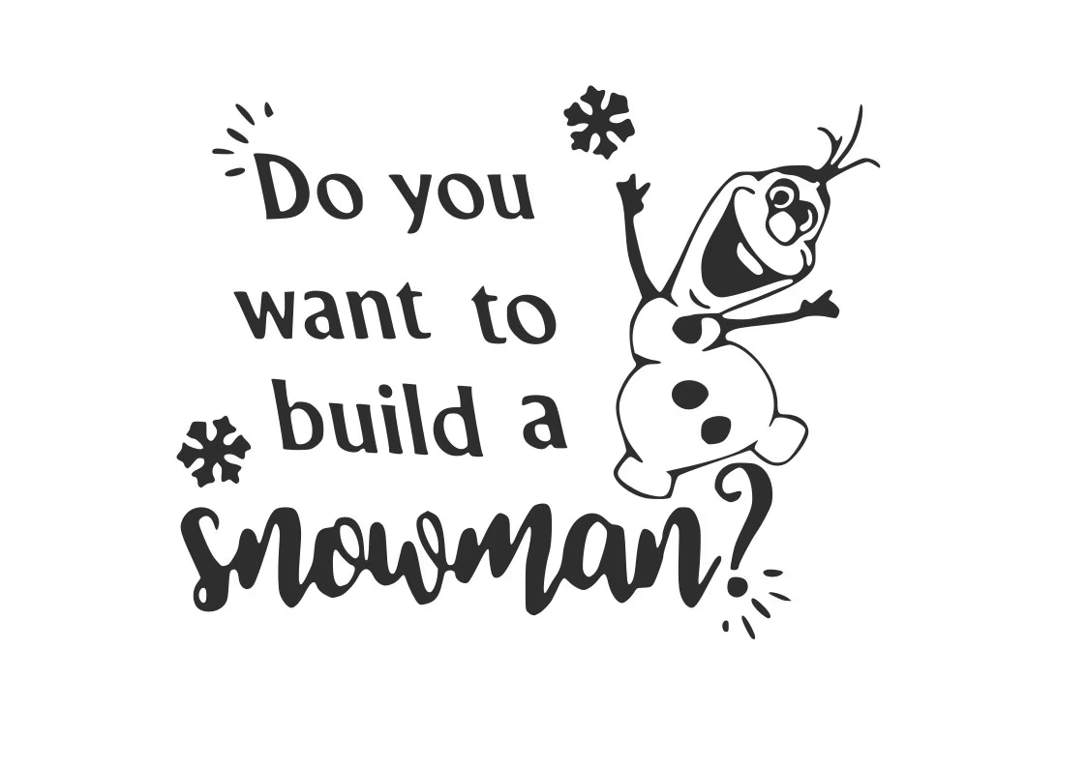
We only have each other
( It’s / does ) just you and me
What ( is / are ) we going to do?
Do you wanna build a snowman?

