You are in Uniqlo
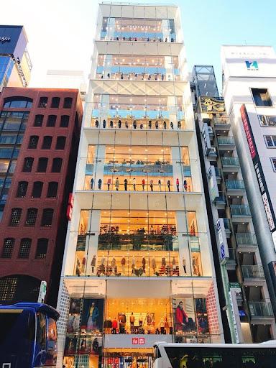
Which Uniqlo store is this? Have you been here?
Clerk: Hello. May I help you?
Customer: Yes, please. I’m ____________________________________
_________________________________________________ some gloves.
Clerk: How about __________________________________?
Customer: That looks ___________________________. How much is it?
Clerk: It’s __________________________________ yen.
Customer: Okay. ___________________________________________!
Clerk: Great.

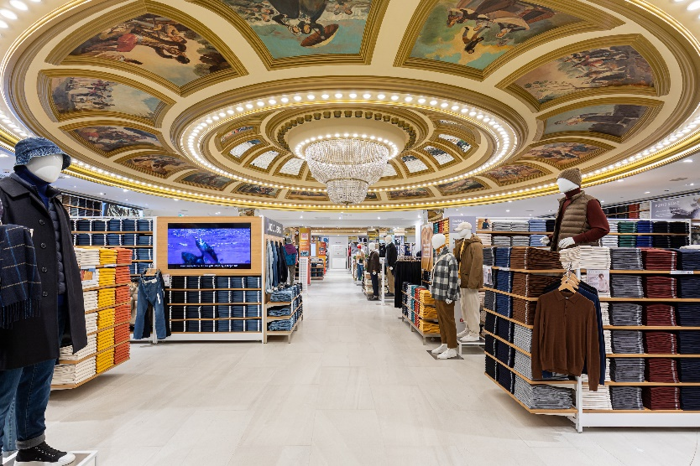
Which Uniqlo store is this? Have you been
here?
Clerk: Hi. __________________________________________________
________________________________________?
Customer: Yes, ____________________. I’m ____________
______________________________________________________________.
Clerk: ______________________________________________________________?
Customer: That looks nice. ______________________________________________________________________?
Clerk: ____________________________________ dollars.
Customer: Ok. I’ll take it!
Clerk: Great.

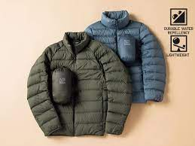

You are in Nike
Nike is the most popular brand for American and Australian teenagers (青少年) in 2023, Do you like Nike?
Clerk: Hi. __________________________________________________?
Customer: Yes, ____________________. I’m _______________________
________________________________________________________________________.
Clerk: ______________________________________________________________?
Customer: That looks nice, but it’s __________________
___________________________________________.
Clerk: Shall I show you a _____________________________________________?
Customer: Yes, please.
Clerk: Here you are.
Customer: Okay. I need to think about it.
Clerk: Sure, no problem.
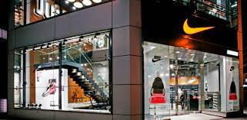

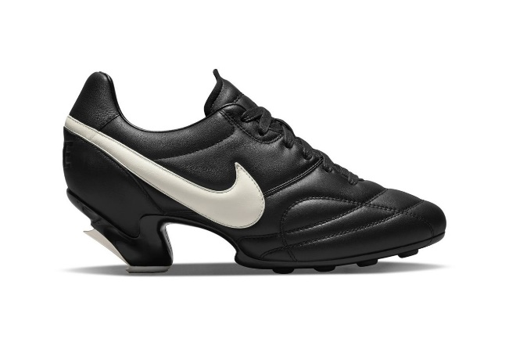

Talk to your partner
Do you like shopping? Why/Why not?
What do you like to buy? Clothes? Games? Books?
Where do you buy them?

