Have you _____________ today?

eat breakfast
go to school
play soccer |  | 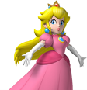
eat lunch
 | 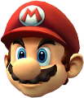
study English
go home
take a bath
sleep

Replies:
- I have not _____________ yet. (まだ～しなかったです。)
- I have just _____________. (さっき～したところです。)
- I have already _______________. (もう～しました。)

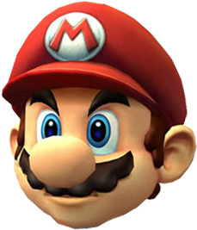 | Mario  ______  ______ | 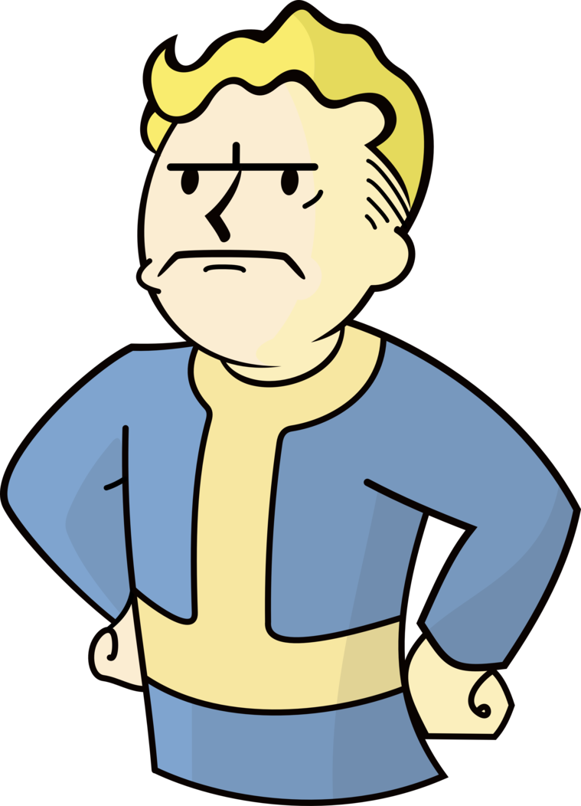 | Paul  ______  ______ |  | Snoopy  ______  ______
 | Kumi  ______  ______ | 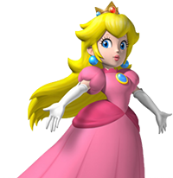 | Peach  ______  ______ |  | Shizuka  ______  ______

