

**Question:**

What did you eat for dinner last night?

**Question:**

What song do you like?

**Question:**

What game do you like?

**Question:**

Do you like ski or snowboard?

**Question:**

What can you do?

**Question:**

What are you good at?

**Question:**

Where is your ALT from?

**Question:**

When is your birthday?



**Question:**

What time is it now?

**Question:**

What is your favourite subject?

**Question:**

What is your name?

**Question:**

What anime do you like?





**Question:**

What time did you get up today?

**Question:**

What did you do last weekend?

**Question:**

What is your favourite season?

**Question:**

What is the date today?



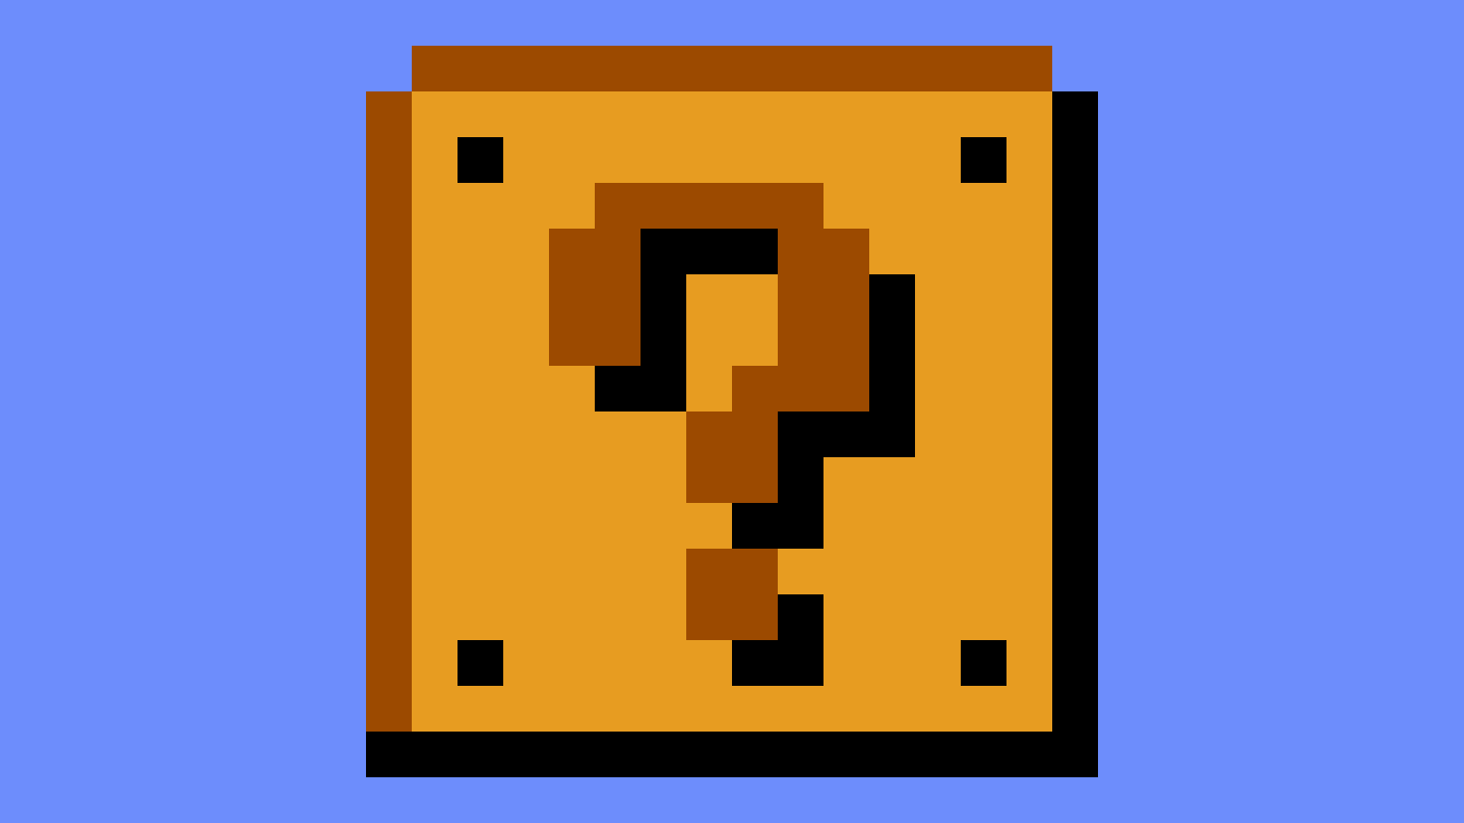





**Go up**

**one row**

**Go up**

**one row**

**Question:**

How's the weather?

**Question:**

How are you?

**BOO**

Take an item from a player!

**BLUE SHELL**

1st person lose a turn and items

**BLUE SHELL**

1st person lose a turn and items

**BANANA**

Put wagomu on space.

Hit player lose a turn.

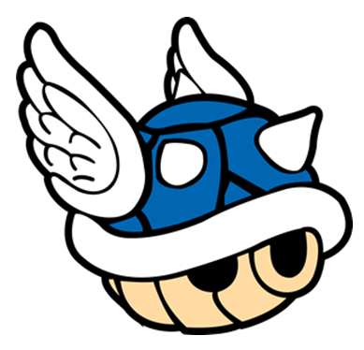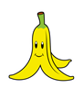

**BOO**

Take an item from a player!

**BANANA**

Put wagomu on space.

Hit player lose a turn.

**FREEZE**

Freeze a player

for 1 turn

**FREEZE**

Freeze a player

for 1 turn

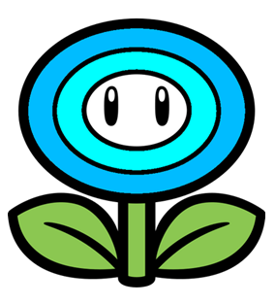

**LOSE A TURN**

**LOSE A TURN**

**STAR!**

**Safe for 5 turns**

**and go up pipes**

**STAR!**

**Safe for 5 turns**

**and go up pipes**

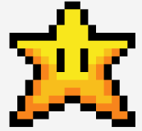







**Roll again!**



**Roll again!**

**Roll again!**

**Roll again!**



**Switch**

**Change places with another player**

**Switch**

**Change places with another player**

**Bullet**

**Go to next player**

**Bullet**

**Go to next player**

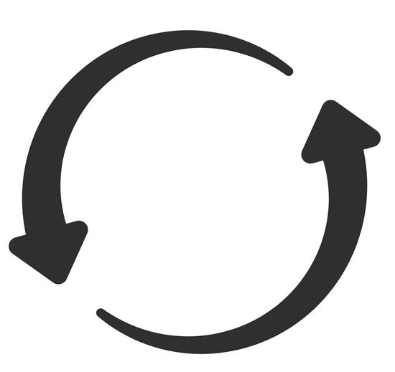

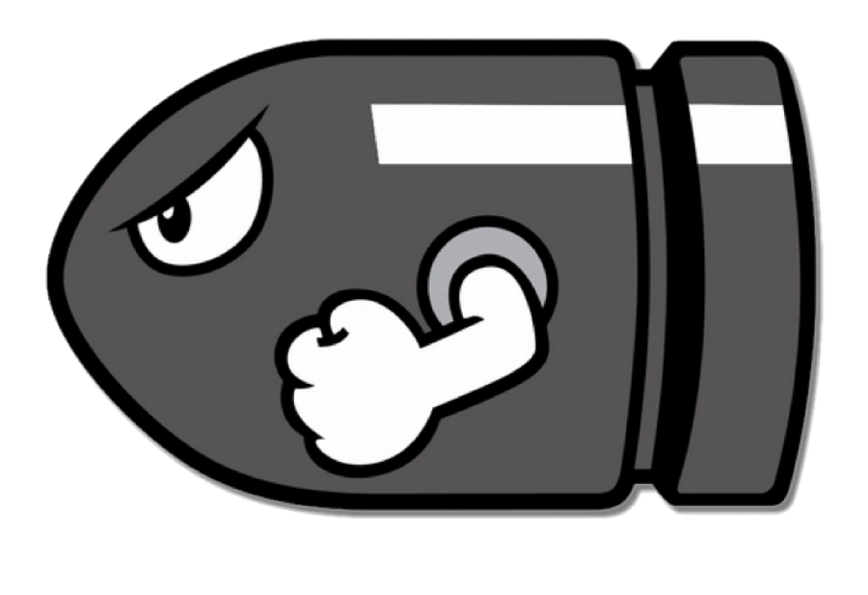

**Fire Flower**

**Kill pakuplant,**

**go up pipe!**

**Fire Flower**

**Kill pakuplant,**

**go up pipe!**

**Fire Flower**

**Kill pakuplant,**

**go up pipe!**

**Fire Flower**

**Kill pakuplant,**

**go up pipe!**

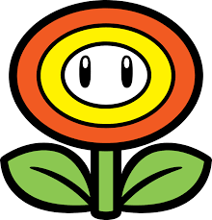



**Bonus**

**Coins!**

**Bonus**

**Coins!**

**Bonus**

**Coins!**

**Bonus**

**Coins!**









**Question:**

What time is it now?

**Question:**

What is your

favourite subject?

**Question:**

What is your name?

**Question:**

Do you like ski or snowboard?



**Bonus!**

**Question:**

What did you do last weekend?

**FREEZE**

Freeze a player

for 1 turn

**FREEZE**

Freeze a player

for 1 turn





**Bonus!**

**Bonus!**

**Bonus!**

**Bonus!**





**BOO**

Take an item from a player!

**BLUE SHELL**

1st person lose a turn and items

**BLUE SHELL**

1st person lose a turn and items

**BANANA**

Put wagomu on space.

Hit player lose a turn.



