|  |  |  |  |
| --- | --- | --- | --- |
| 23,711 Black Border Clipart Royalty-Free Images, Stock Photos & Pictures |  Shutterstock | Blank Clock | ClipArt ETC  I ____________  ____________  at |  |  |
| Good Night! | **This**  **Is**  **_______**  **Day** |  |  |

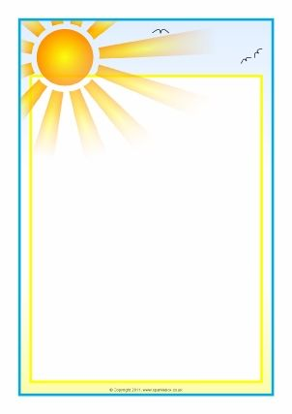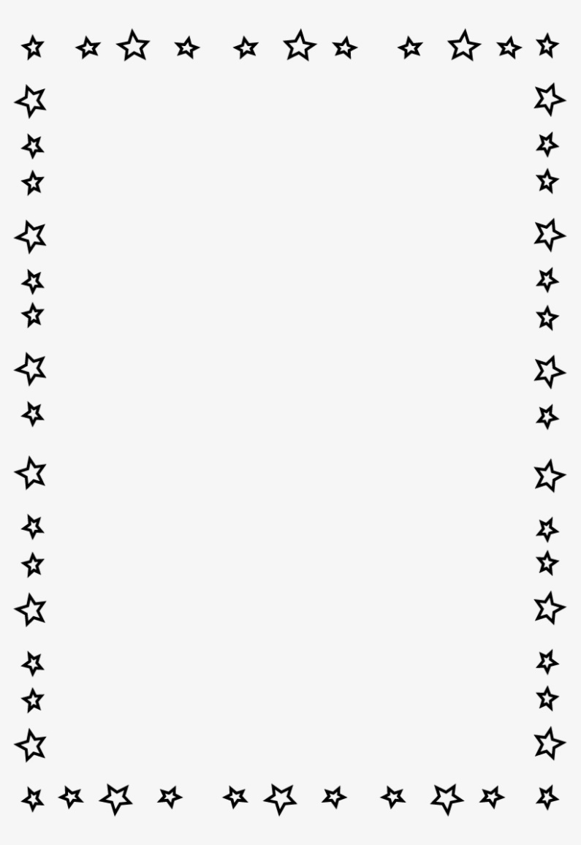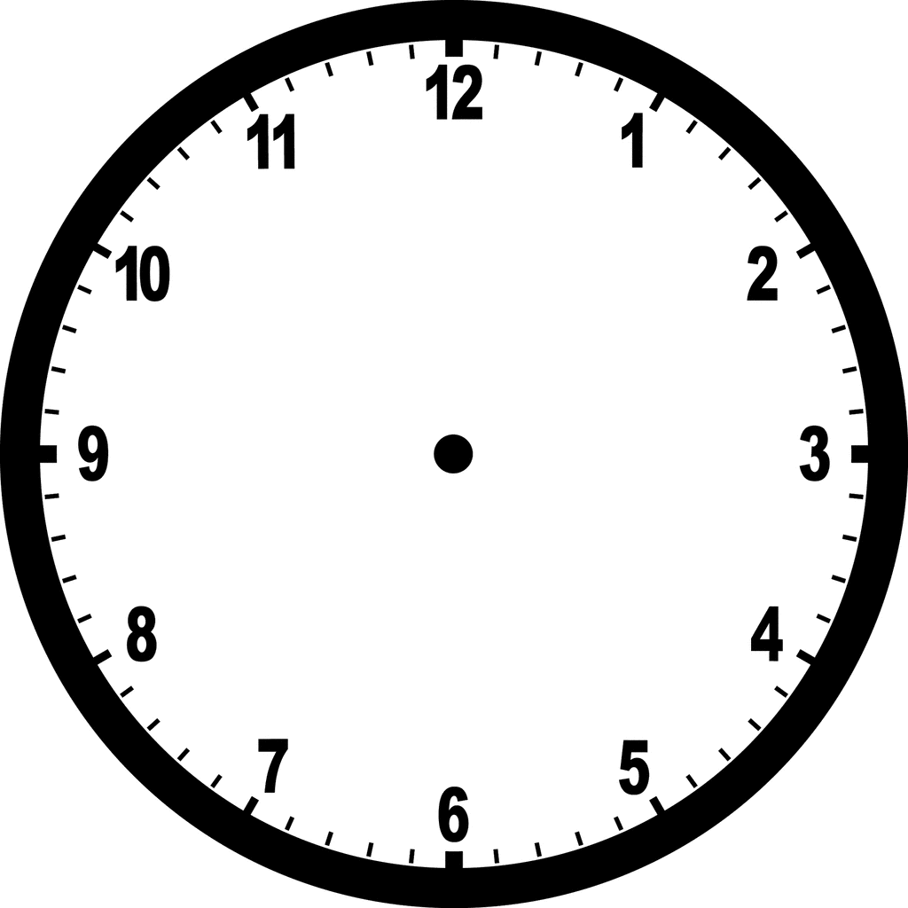

I ____________

____________

at

I ____________

____________

at