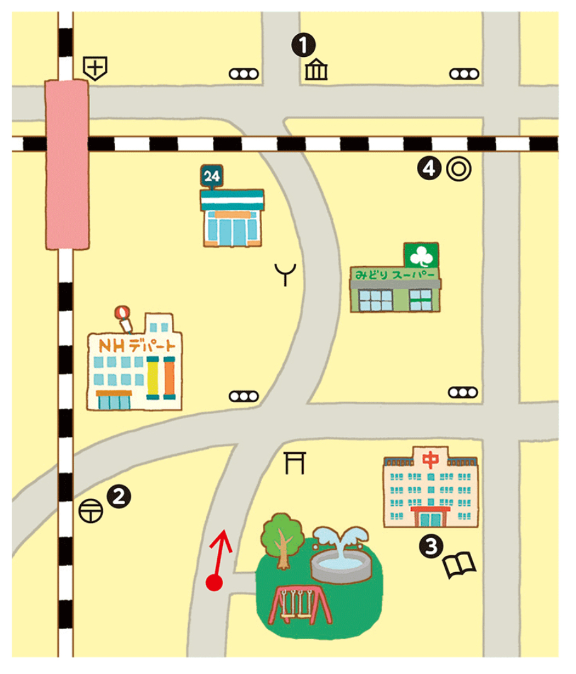
Asking Directions!
the shrine
the fire station
the post office
the park
the library
the supermarket
the museum
City Hall
the hospital
the convenience store
NH department store
Toolbox

Use the map above to complete the dialogue below.
Man: Excuse me. I’m looking for ____________________________________.
You: Pardon me?
Man: Where is _________________________________?
You: Let’s see ．．．.
Go _____________________________________________________________.
Turn ( left / right ) at the ( first / second ) traffic light.
You can see it on your ( left / right ).
It’s by _______________________________________________.
Man: Thank you.
You: You’re welcome.

Let’s practice with your friends!

