Name: _______________________

Can you play shogi?

Sign please.

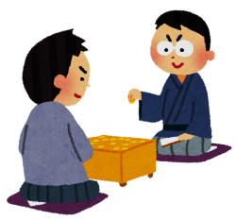

Yes, I can.

Sign Game!

**Part 1.** Ask your classmates!

Q: Can you ? A: Yes, I can. → Sign Please

No, I can’t. → Good-bye!

|  |  |  |  |  |  |
| --- | --- | --- | --- | --- | --- |
| play table tennis | make sushi | snowboard | sing an English song | eat 5 cheeseburgers | play the piano  Goal! |
| http://1.bp.blogspot.com/_Nuqma_j336E/TCyyZMAWW7I/AAAAAAAAAAU/I9JmjrDvjL8/s1600/2.gif | http://3.bp.blogspot.com/-q9jrBNzd6Lo/T2pwtitRluI/AAAAAAAAE1Y/8K1-nQ9gUNI/s1600/food_sushi.png | http://www.picgifs.com/sport-graphics/sport-graphics/snowboarding/sport-graphics-snowboarding-394599.gif |  |  | http://static.freepik.com/free-photo/piano-clip-art_435730.jpg |
|  |  |  |  |  |  |