Do you have to eat breakfast every day?  _____________________ | Do you have to walk to school every day?  _____________________ | Do you have to clean the dishes?  _____________________ | Do you have to do the laundry?  _____________________
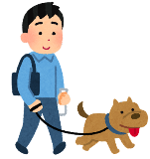  Do you have to walk the dog?  _____________________ | Do you have to do your homework?  _____________________ | 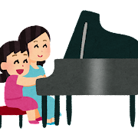  Do you have to practice the piano?  _____________________ | 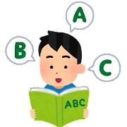  Do you have to study English?  _____________________
Do you have to go food shopping?  _____________________ | 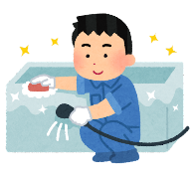  Do you have to clean the bathtub?  _____________________ | 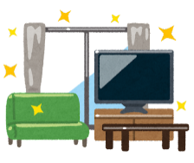  Do you have to clean your room?  _____________________ | Do you have to cook dinner?  _____________________
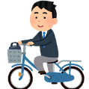  Do you have to go to school by bike?  _____________________ | Do you have to say “itadakimasu”?  _____________________ | Do you have to drink milk for lunch?  _____________________ | Do you have to go to club activities?  _____________________

A: Do you have to ~~? B: Yes, I do Write your partner’s name
No, I don’t Ask a new question

Write each name only once! ALT and JTE are also okay!

