Let’s Have a Mini Debate – Planning (pp. 102-5)
司会：(1人)
※司会は審判の役割も担います。
1) ||||||||||||||||||||||||||||||||||||||
反論・質問する人：(2~3人)
1) ||||||||||||||||||||||||||||||||||||||
2) ||||||||||||||||||||||||||||||||||||||
3) ||||||||||||||||||||||||||||||||||||||
理由を述べる人：(2~3人)
1) ||||||||||||||||||||||||||||||||||||||
2) ||||||||||||||||||||||||||||||||||||||
3) ||||||||||||||||||||||||||||||||||||||
Name: __________________ Class: ___

題（Topic） | ☐ #1 School lunches are better than boxed lunches.  ☐ #2 Dogs are better than cats.  ☐ #3 Summer is a better season than winter.  ☐ #4 It’s better to live in the countryside than in cities.  ☐ #5 Money is more important than love.  ☐ #6 All kids over 10 should have smartphones.  ☐ #7 e-Learning is better than classroom learning.  ☐ #8 Tokyo is better than Osaka.
立場 | We 【 agree / disagree 】 with this idea.
司会:ディベートがスムーズに進み、時間オーバーにならないようにしなければなりません。
 | 流れ | 時間
1 | 主張（賛成） | 1分
2 | 主張（反対） | 1分
3 | 作戦タイム | 3~5分
4 | 質疑（反対） | 3分
5 | 質疑（賛成） | 3分
6 | 判定 | 1~2分

MEMO FOR JUDGE
司会・審判用
13～15分

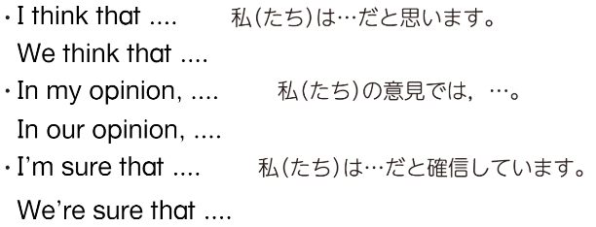
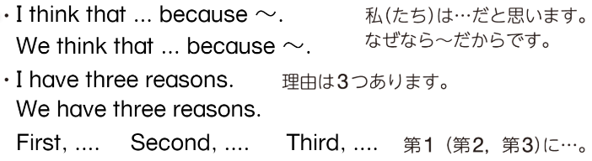
賛成:
理由を述べる
意見を述べる

反対:

反論するとき
反対:
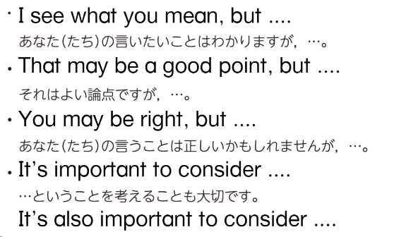

賛成:

OPPOSING TEAM’S ARGUMENT POINTS相手チームの述べた理由
FREE MEMO自由メモ
司会： Let’s start a mini debate. Today’s topic is “|||||||||||||||||||||||||||||||||||||||||||||||||||||||||||||||||”
(ミニディベートを始めましょう。今日の論題は「〇〇」です。)
First, we’ll hear from people who agree. (最初に，賛成側の人たちから意見を聞きましょう。)
賛成側： We think that ||||||||||||||||||||||||||||||||||||||||||||||||||||||||||||||||||||||||||||||||||||||||||||||||.
(私たちは〇〇と思います。)
We have three reasons. (理由は3つあります。)
First, |||||||||||||||||||||||||||||||||||||||||||||||||||||||||||||||||||||||||||||||||||||||||||||||||||||||||||||||||||||||||.
Second, |||||||||||||||||||||||||||||||||||||||||||||||||||||||||||||||||||||||||||||||||||||||||||||||||||||||||||||||||||||.
Third, ||||||||||||||||||||||||||||||||||||||||||||||||||||||||||||||||||||||||||||||||||||||||||||||||||||||||||||||||||||||||.
司会： Thank you. Next, we’ll hear from people who disagree.
(ありがとうございます。次は，反対側の人たちから意見を聞きましょう。)
反対側： We don’t think that ||||||||||||||||||||||||||||||||||||||||||||||||||||||||||||||||||||||||||||||||||||||||.
(私たちは〇〇とは思いません。)
First, |||||||||||||||||||||||||||||||||||||||||||||||||||||||||||||||||||||||||||||||||||||||||||||||||||||||||||||||||||||||||.
Second, |||||||||||||||||||||||||||||||||||||||||||||||||||||||||||||||||||||||||||||||||||||||||||||||||||||||||||||||||||||.
Third, ||||||||||||||||||||||||||||||||||||||||||||||||||||||||||||||||||||||||||||||||||||||||||||||||||||||||||||||||||||||||.
司会： Thank you. It’s time to think about questions to ask each other.

司会： Okay, let’s move on to questions and answers. (それでは質疑応答に移りましょう。)
People who disagree, please ask your questions first. (反対側の人たちは先に質問をしてください。)
反対側： |||||||||||||||||||||||||||||||||||||||||||||||||||||||||||||||||||||||||||||||||||||||||||||||||||||||||||||||||||||||||||||||||
賛成側： |||||||||||||||||||||||||||||||||||||||||||||||||||||||||||||||||||||||||||||||||||||||||||||||||||||||||||||||||||||||||||||||||
反対側(任意)：||||||||||||||||||||||||||||||||||||||||||||||||||||||||||||||||||||||||||||||||||||||||||||||||||||||||||||||||||||||||||||
賛成側(任意)：||||||||||||||||||||||||||||||||||||||||||||||||||||||||||||||||||||||||||||||||||||||||||||||||||||||||||||||||||||||||||||
司会： Thank you very much. I will now judge and choose the winner.
(ありがとうございます。これから私が審査し、優勝者を選びます。)
People who (agree / disagree) made better points. So, they’re the winners of this debate.
(【賛成・反対】側の人たちのほうがよりよい論点を展開しました。そのため，【賛成・反対】がこのディベートの勝者です。)

(ありがとうございます。今から相手チームへの質問を考える時間です。)
Mini Debate Flow（ミニディベートの流れ）

