When is your Birthday?

What’s your name in Romaji?

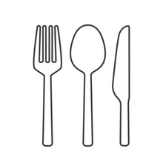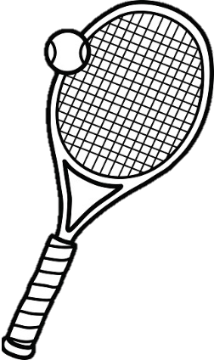

____________________

________________

What sport do you like?

______________________

______________________

______________________

______________________



What food do you like?

_______________



What animal do you like?

What color do you like?

_____________________