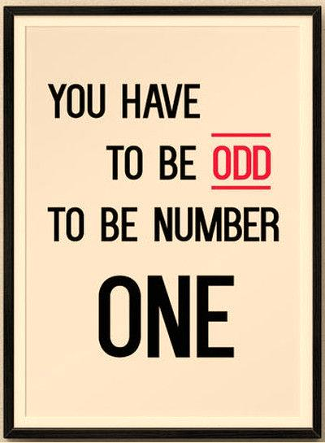
Name: ______________________________ Number: ______ Class: _____

I have to _______________________________________ every morning. How about you?
Me, too Boxes
I have to __________________________________ on _________________. How about you?
Me, too Boxes
I don’t have to _______________________________________ after _____________. How about you?
Me,too Boxes
I don’t have to________________________________________ at ________________. How about you?
Me, too Boxes

