Name: ___________ Class: ____ Number: ____ Date: ___/____
ELECTION USA

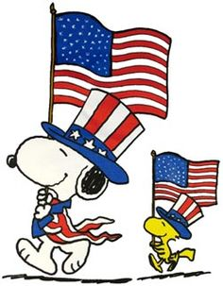

presents | cookies | family | dog
bike | face | tools | hat
feet | rings | flag | cat
his/his her/hers my/mine our/ours their/theirs Bob’s/Bob’s
its/its your/yours
- It ____ ___________ _________/_____________________________
- It _____ ________ ___________/_____________________________
- They ____ _______ ___________/_____________________________
- It _____ _______ ____________/_____________________________
- It _____ _______ ____________/_____________________________
- They _____ ________ ________/_____________________________
- They ______ _____________/_____________________________
- It ______ _______________/_____________________________
- They ______ _____________/_____________________________
- It ______ ____________/______________________________
- ___They ______ _________/_____________________________
- It ______ ___________/______________________________
Example
- Whose house is this?
- Whose ears are these?

QUESTIONS
- Whose hat is this?
- Whose dog is this?
- Whose presents are these?
- Whose face is this?
- Whose bike is this?
- Whose rings are these?
- Whose cookies are these?
- Whose family is this?
- Whose tools are these?
- Whose cat is this?
- Whose feet are these?
- Whose flag is this?

