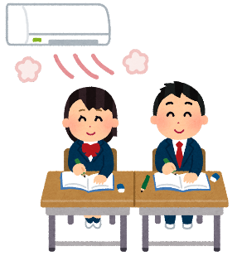

Graduation!

Time to reflect, and look to the future!

1. **What’s your favourite memory from (INSERT SCHOOL) junior high school?**

＿＿＿＿＿＿＿＿＿＿＿＿＿＿＿＿＿＿＿＿＿＿＿＿＿＿＿＿＿＿＿＿＿＿.

1. **What are you excited to do at high school?**

＿＿＿＿＿＿＿＿＿＿＿＿＿＿＿＿＿＿＿＿＿＿＿＿＿＿＿＿＿＿＿＿＿＿.

1. **What did your classmates do that made you happy?**

＿＿＿＿＿＿＿＿＿＿＿＿＿＿＿＿＿＿＿＿＿＿＿＿＿＿＿＿＿＿＿＿＿＿.

1. **What is your advice for 1st & 2nd grade students?**

＿＿＿＿＿＿＿＿＿＿＿＿＿＿＿＿＿＿＿＿＿＿＿＿＿＿＿＿＿＿＿＿＿＿.



Graduation!

Time to reflect, and look to the future!

1. **What’s your favourite memory from (INSERT SCHOOL) junior high school?**

＿＿＿＿＿＿＿＿＿＿＿＿＿＿＿＿＿＿＿＿＿＿＿＿＿＿＿＿＿＿＿＿＿＿.

1. **What are you excited to do at high school?**

＿＿＿＿＿＿＿＿＿＿＿＿＿＿＿＿＿＿＿＿＿＿＿＿＿＿＿＿＿＿＿＿＿＿.

1. **What did your classmates do that made you happy?**

＿＿＿＿＿＿＿＿＿＿＿＿＿＿＿＿＿＿＿＿＿＿＿＿＿＿＿＿＿＿＿＿＿＿.

1. **What is your advice for 1st & 2nd grade students?**

＿＿＿＿＿＿＿＿＿＿＿＿＿＿＿＿＿＿＿＿＿＿＿＿＿＿＿＿＿＿＿＿＿＿.