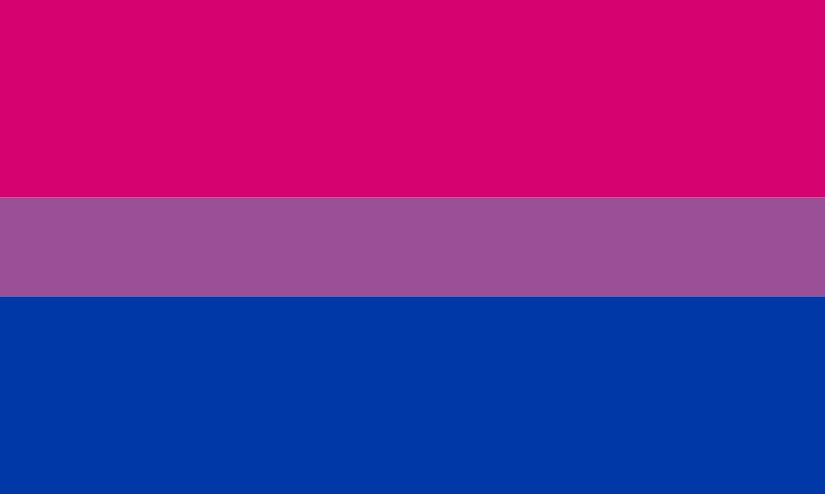
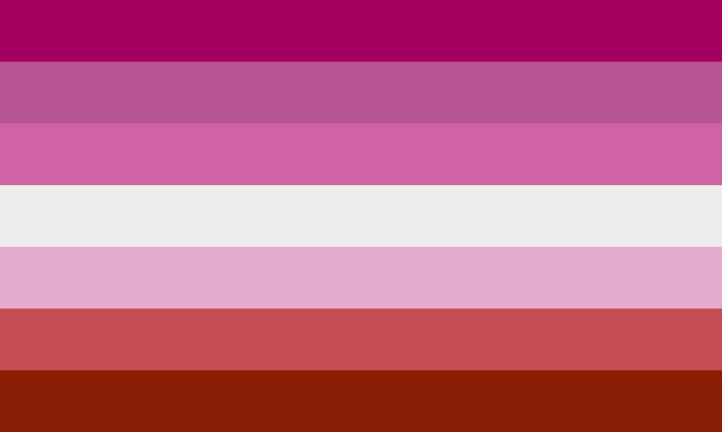
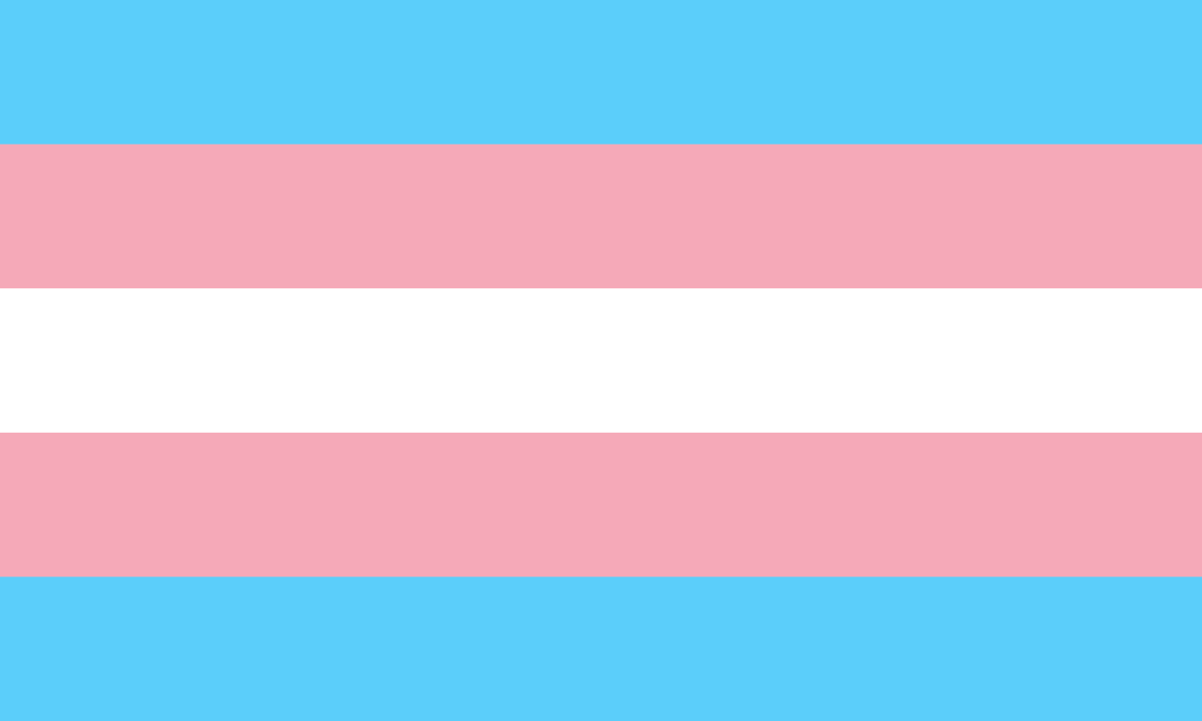
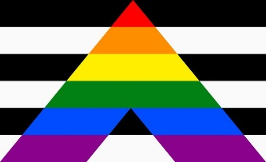
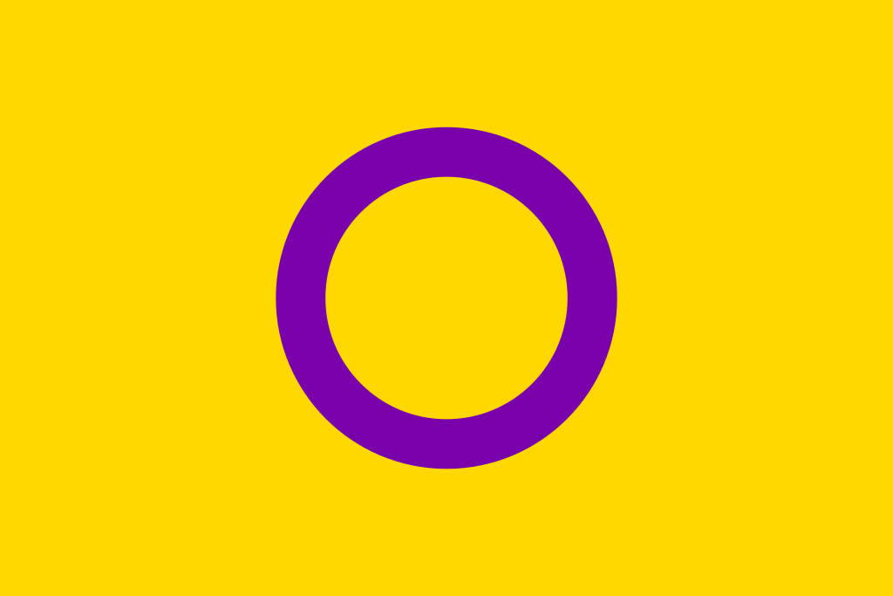
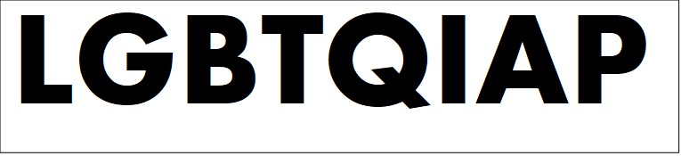
LGBT+
Pride Flags
LGBTQIAP
レスビアン
1. This is the Lesbian Pride Flag. It has 7 colors: 3 pinks, 1 white, and 3 reds. Its birthday is July 2010.

2. This is the LGBT+ Pride flag. Its nickname is the Rainbow flag. It is 43 years old. It has 6 colors: red, orange, yellow, green, blue, and purple.

マイケル・ページ
3. In 1988, Michael Page made the Bisexual Pride flag. It’s for people who like girls and boys. It has 3 colors: pink, purple, and blue.
バイセクシャル

トランスジェンダー
4. This is the Transgender Pride flag. It has 3 colors. Light blue is for baby boys. Next is pink, the color for girls. White is for people who are not boys or girls or x-gender. It’s 22 years old.
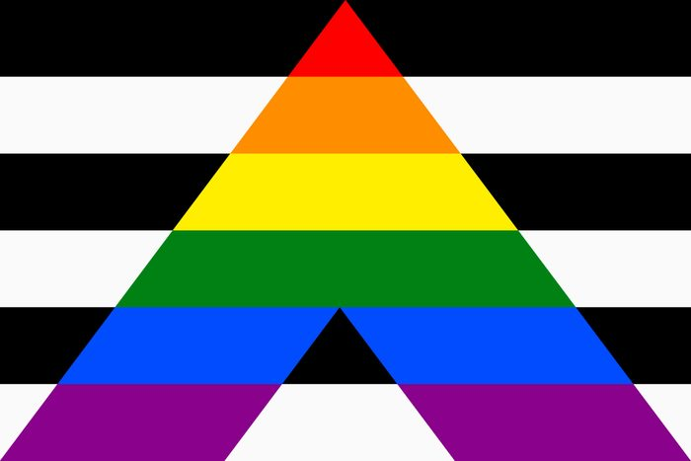
ストレートアライ
5. This is the Straight Ally Pride flag. There are 8 colors. The A is the Rainbow flag. Black and white is for friends of LGBT+ people. It was made in 2000.

Dictionary:
ally or straight ally (味方):
LGBT+ 当事者たちに共感し、寄り添いたいと考え、支援する人のこと。
A friend of LGBT+ people.
bisexual (両性愛者):
男性と女性が好き。One person likes men AND women.
gay (男性の両性愛者):
心の性が男性で男性が好き。A man loves a man.
gender (性自認):
自分の性をどのように認識しているのか、ということ。多くの人は「身体の性」と「心の性」が一致しているが、「身体の性」と「心の性」が一致せずそれから男性でも女性でもない性自認を持つ人たちもいる。
Who you are. Girl, boy, both or neither. Everyone has a gender.
lesbian (女性の両性愛者):
心の性が女性で女性が好き。A woman loves a woman.
transgender:
主に身体的な性別と性自認が一致しない人。例えば、身体の性が男性でも心の性は女性。
Born a boy, but they are a woman inside OR born a girl, but they are a man inside.

x-gender / nonbinary:
心の性が女性、男性のどちらかに規定できない/しない人のこと。
A person who is not a girl and not a boy.

Hello.

Pride Month June 2021 Group names:____________________________________
This is the _______________________________________ flag.
____________________ is “_________________” in Japanese.
It is _______ years old. It has ________ colors: ________
数
数
___________________________________________________.
はたの色
Thank you.

Pride Month June 2021 Group names:____________________________________
Hello.
This is the _______________________________________ flag.
____________________ is “_________________” in Japanese.
It is _______ years old. It has ________ colors: ________
数
数
___________________________________________________.
はたの色
Thank you.

