Hi, how are you?

I’m fine, thanks, and you?

I’m good, thanks.

What TV program do you like?

I like ItteQ. It’s great.

Cool. Cool. Me, too.

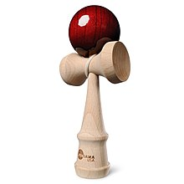
What sport do you like?

I like basketball. It’s fun.

Nice. I like dodge ball.

Cool. Me, too. What time do you play?

I play at 1:10.

