ACTIVE or PASSIVE?
- Circle the correct answer
- I ate two slices of cake today.
(Active/ Passive)
- The teacher reads a book to the students.
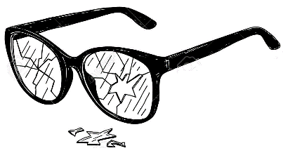
(Active/ Passive)
- My glasses are broken.
(Active/Passive)
- Ken bought a watch in the Aeon Mall.
(Active/ Passive)
- He took a shower three hours ago.
(Active/ Passive)
- English is spoken in Australia, too.
(Active/ Passive)
- The pineapples were grown in the Philippines.
(Active/ Passive)
- Emily sees her friends at school every day. .
(Active/ Passive)
- Momoka’s new bag was bought on Amazon.
(Active/ Passive)
- That song was sung by BTS.
(Active/ Passive)
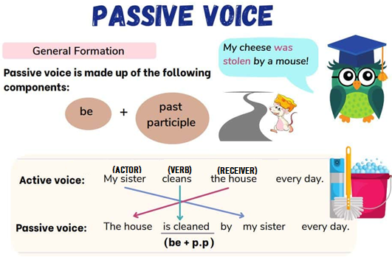

- Change the sentences from Active Voice to Passive Voice.
- Ms. Brown eats the last slice of bread,
______________________________________________________.
- Everyone saw the stars last night.
______________________________________________________.
- Ohtani Shohei hits a home run in the stadium.
______________________________________________________
- Usain Bolt ran the 100 m race in 9.54 seconds.
______________________________________________________
- Eri buys apples and carrots at the market.
______________________________________________________

