Hi, how are you?

I’m fine, thanks, and you?

I’m good, thanks.

What time do you get up?

I get up at 6:00.

Cool. I get up at 5:30.

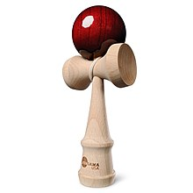
Amazing! What time do you go to bed?

I go to bed at 9:00.

I go to bed at 11:00. I usually play games.

Wow. I never play games. I usually watch TV.

Nice. I like ItteQ.

